**Binary Search Tree**

A Binary Search Tree is a special form of a binary tree. The value in each node must be greater than (or equal to) any values in its left subtree but less than (or equal to) any values in its right subtree.

We'll go through this definition more specifically in this chapter and provide you some exercise related to the binary search tree.

The goal of this card is to:

1. Understand the properties of a binary tree;
2. Be able to do basic operations in a binary search tree;
3. Understand the concept of a height-balanced binary search tree

Introduction to BST

 Definition of the Binary Search Tree

 Validate Binary Search Tree

 Inorder Successor in BST

 Binary Search Tree Iterator

Basic Operations in BST

 Search in a BST - Introduction

 Search in a Binary Search Tree

 Search in a BST - Solution

 Insertion in a Binary Search Tree - Introduction

 Insert into a Binary Search Tree

 Insertion in a BST - Solution

 Deletion in a BST - Introduction

 Delete Node in a BST

 Deletion in a BST - Solution

Conclusion

 Introduction to Binary Search Tree - Conclusion

 Kth Largest Element in a Stream

 Kth Largest Element in a Stream - Solution

 Lowest Common Ancestor of a Binary Search Tree

 Contains Duplicate III

Appendix: Height-balanced BST

 Introduction to the Height-Balanced BST

 Balanced Binary Tree

 Convert Sorted Array to Binary Search Tree

Introduction to BST

In this chapter, we will introduce what is a binary search tree. By understanding the useful properties, you will be able to solve problems related to a BST and use this data structure properly.

**Definition of the Binary Search Tree**

A binary search tree (BST), a special form of a binary tree, satisfies the binary search property:

1. The value in each node must be greater than (or equal to) any values stored in its left subtree.
2. The value in each node must be less than (or equal to) any values stored in its right subtree.

Here is an example of a BST.

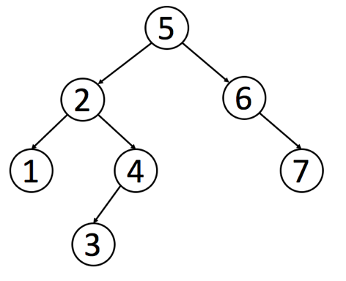

We have exercises for you to validate a BST after this article. You can use the property we mentioned above to determine whether a binary tree is a BST or not. The recursive thinking we have introduced in the previous chapter might help you with this problem.

Like a normal binary tree, we can traverse a BST in preorder, inorder, postorder or level-order. However, it is noteworthy that inorder traversal in BST will be in ascending order. Therefore, the inorder traversal is the most frequent used traversal method of a BST.

We also have exercises for you to find the inorder successor in a BST after this article. Obviously, you can do the inorder traversal to find the inorder successor in a BST. But please try to apply the property of the BST we have learned to find out a better way to solve this problem.

**Validate Binary Search Tree**

Given the root of a binary tree, *determine if it is a valid binary search tree (BST)*.

A **valid BST** is defined as follows:

* The left subtree of a node contains only nodes with keys **less than** the node's key.
* The right subtree of a node contains only nodes with keys **greater than** the node's key.
* Both the left and right subtrees must also be binary search trees.

**Example 1:**

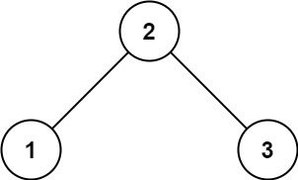

**Input:** root = [2,1,3]

**Output:** true

**Example 2:**

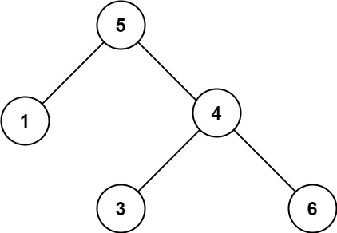

**Input:** root = [5,1,4,null,null,3,6]

**Output:** false

**Explanation:** The root node's value is 5 but its right child's value is 4.

**Constraints:**

* The number of nodes in the tree is in the range [1, 104].
* -231 <= Node.val <= 231 - 1

## Solution Article

#### **Tree definition**

First of all, here is the definition of the TreeNode which we would use.

|  |
| --- |
| // Definition for a binary tree node.  public class TreeNode {  int val;  TreeNode left;  TreeNode right;  TreeNode(int x) {  val = x;  }  } |

#### **Intuition**

On the first sight, the problem is trivial. Let's traverse the tree and check at each step if node.right.val > node.val and node.left.val < node.val. This approach would even work for some trees   
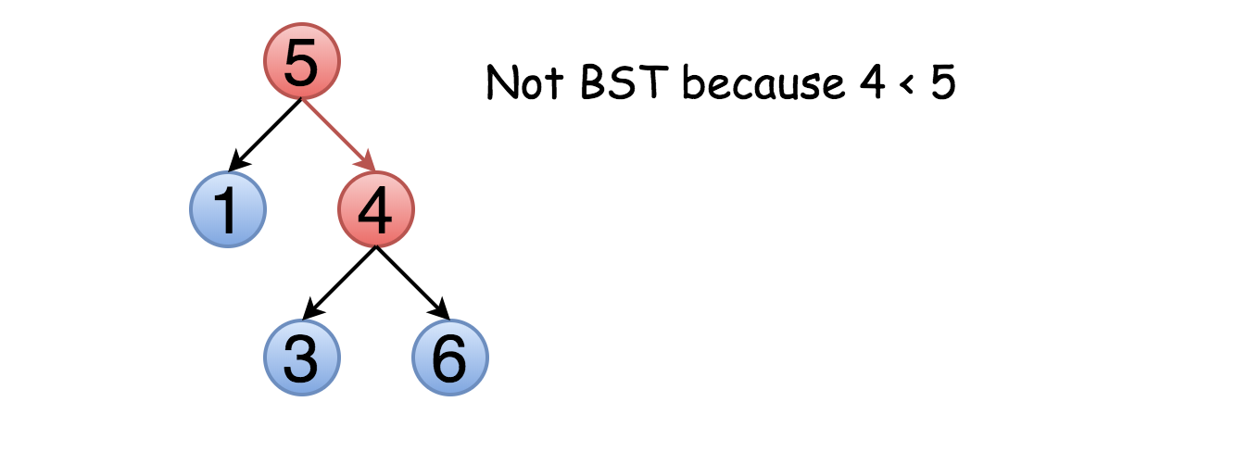

The problem is this approach will not work for all cases. Not only the right child should be larger than the node but all the elements in the right subtree. Here is an example :

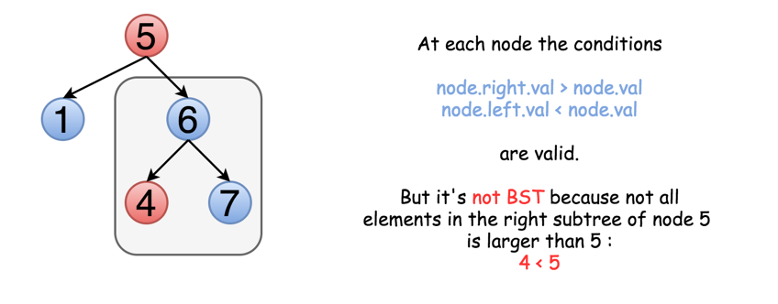

That means one should keep both upper and lower limits for each node while traversing the tree, and compare the node value not with children values but with these limits.

#### **Approach 1: Recursive Traversal with Valid Range**

The idea above could be implemented as a recursion. One compares the node value with its upper and lower limits if they are available. Then one repeats the same step recursively for left and right subtrees.

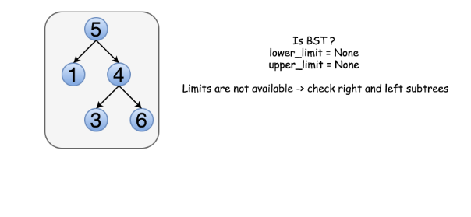

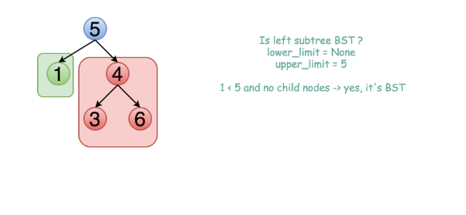

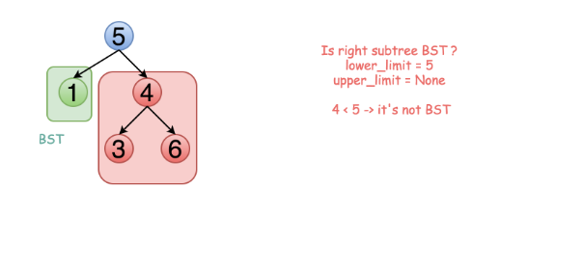

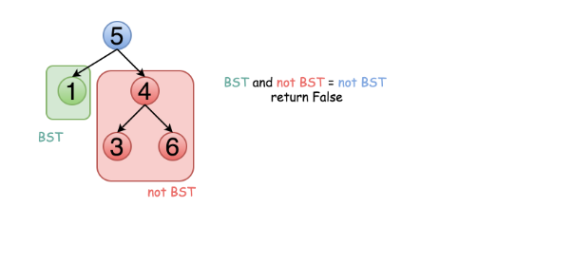

|  |
| --- |
| class Solution {  public boolean validate(TreeNode root, Integer low, Integer high) {  // Empty trees are valid BSTs.  if (root == null) {  return true;  }  // The current node's value must be between low and high.  if ((low != null && root.val <= low) || (high != null && root.val >= high)) {  return false;  }  // The left and right subtree must also be valid.  return validate(root.right, root.val, high) && validate(root.left, low, root.val);  }  public boolean isValidBST(TreeNode root) {  return validate(root, null, null);  }  } |

**Complexity Analysis**

* Time complexity : O(*N*) since we visit each node exactly once.
* Space complexity : O(*N*) since we keep up to the entire tree.

#### **Approach 2: Iterative Traversal with Valid Range**

The above recursion could be converted into iteration, with the help of an explicit stack. DFS would be better than BFS since it works faster here.

|  |
| --- |
| class Solution {  private Deque<TreeNode> stack = new LinkedList();  private Deque<Integer> upperLimits = new LinkedList();  private Deque<Integer> lowerLimits = new LinkedList();  public void update(TreeNode root, Integer low, Integer high) {  stack.add(root);  lowerLimits.add(low);  upperLimits.add(high);  }  public boolean isValidBST(TreeNode root) {  Integer low = null, high = null, val;  update(root, low, high);  while (!stack.isEmpty()) {  root = stack.poll();  low = lowerLimits.poll();  high = upperLimits.poll();  if (root == null) continue;  val = root.val;  if (low != null && val <= low) {  return false;  }  if (high != null && val >= high) {  return false;  }  update(root.right, val, high);  update(root.left, low, val);  }  return true;  }  } |

**Complexity Analysis**

* Time complexity : O(*N*) since we visit each node exactly once.
* Space complexity : O(*N*) since we keep up to the entire tree.

#### **Approach 3: Recursive Inorder Traversal**

**Algorithm**

Let's use the order of nodes in the [inorder traversal](https://leetcode.com/articles/binary-tree-inorder-traversal/) Left -> Node -> Right.

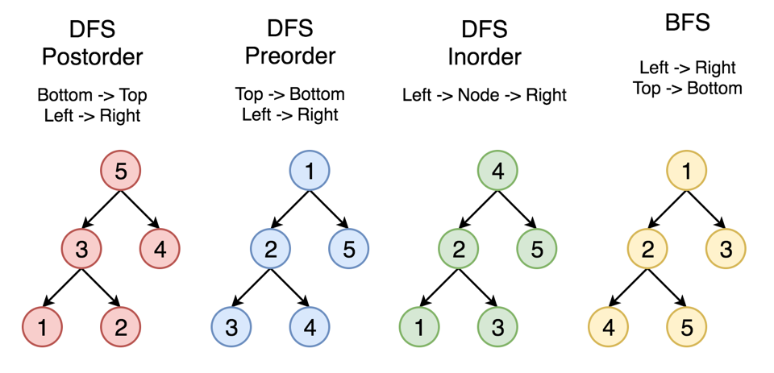

Here the nodes are enumerated in the order you visit them, and you could follow 1-2-3-4-5 to compare different strategies.

Left -> Node -> Right order of inorder traversal means for BST that each element should be smaller than the next one.

Hence the algorithm with O(*N*) time complexity and O(*N*) space complexity could be simple:

* Compute inorder traversal list inorder.
* Check if each element in inorder is smaller than the next one.

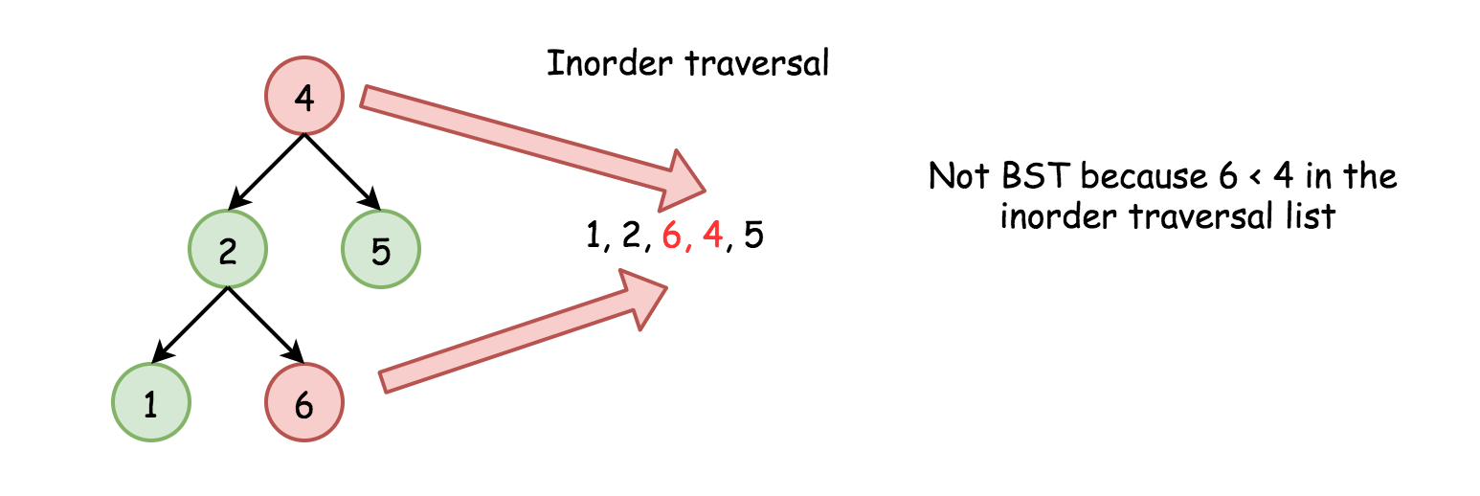

Do we need to keep the whole inorder traversal list?

Actually, no. The last added inorder element is enough to ensure at each step that the tree is BST (or not). Hence one could merge both steps into one and reduce the used space.

**Code**

We can implement the algorithm recursively.

|  |
| --- |
| class Solution {  // We use Integer instead of int as it supports a null value.  private Integer prev;  public boolean isValidBST(TreeNode root) {  prev = null;  return inorder(root);  }  private boolean inorder(TreeNode root) {  if (root == null) {  return true;  }  if (!inorder(root.left)) {  return false;  }  if (prev != null && root.val <= prev) {  return false;  }  prev = root.val;  return inorder(root.right);  }  } |

**Complexity Analysis**

* Time complexity : O(*N*) in the worst case when the tree is a BST or the "bad" element is a rightmost leaf.
* Space complexity : O(*N*) for the space on the run-time stack.

#### **Approach 4: Iterative Inorder Traversal**

Alternatively, we could implement the above algorithm iteratively.

|  |
| --- |
| class Solution {  public boolean isValidBST(TreeNode root) {  Deque<TreeNode> stack = new ArrayDeque<>();  Integer prev = null;  while (!stack.isEmpty() || root != null) {  while (root != null) {  stack.push(root);  root = root.left;  }  root = stack.pop();  // If next element in inorder traversal  // is smaller than the previous one  // that's not BST.  if (prev != null && root.val <= prev) {  return false;  }  prev = root.val;  root = root.right;  }  return true;  }  } |

**Complexity Analysis**

* Time complexity : O(*N*) in the worst case when the tree is BST or the "bad" element is a rightmost leaf.
* Space complexity : O(*N*) to keep stack.

**Inorder Successor in BST**

Given a binary search tree and a node in it, find the in-order successor of that node in the BST.

The successor of a node p is the node with the smallest key greater than p.val.

**Example 1:**

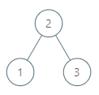

**Input:** root = [2,1,3], p = 1

**Output:** 2

**Explanation:** 1's in-order successor node is 2. Note that both p and the return value is of TreeNode type.

**Example 2:**

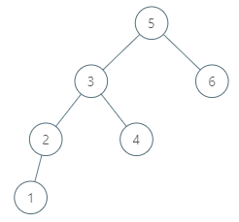

**Input:** root = [5,3,6,2,4,null,null,1], p = 6

**Output:** null

**Explanation:** There is no in-order successor of the current node, so the answer is null.

**Note:**

1. If the given node has no in-order successor in the tree, return null.
2. It's guaranteed that the values of the tree are unique.

## Solution

#### **Approach 1: Iterative Inorder Traversal**

[Inorder traversal of BST is an array sorted in the ascending order](https://leetcode.com/articles/delete-node-in-a-bst/).

Successor is the smallest node in the inorder traversal after the current one.

There could be two situations :

1. If the node has a right child, the successor is somewhere lower in the tree, see red nodes on the Fig. below.
2. Otherwise, the successor is somewhere upper in the tree, see blue nodes on the Fig.

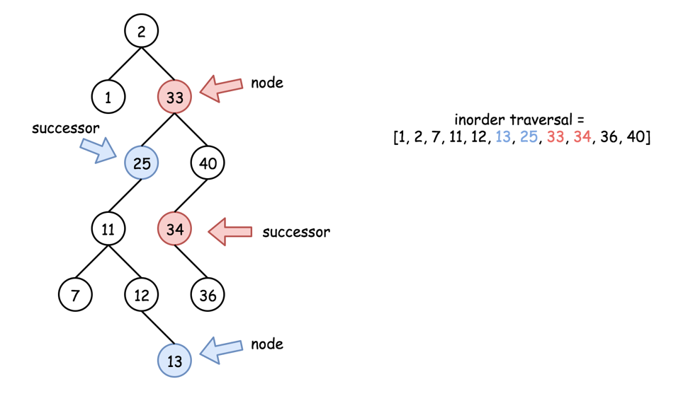

Let's first check the simple case 1. To find a successor, go one step right and then left till you can.

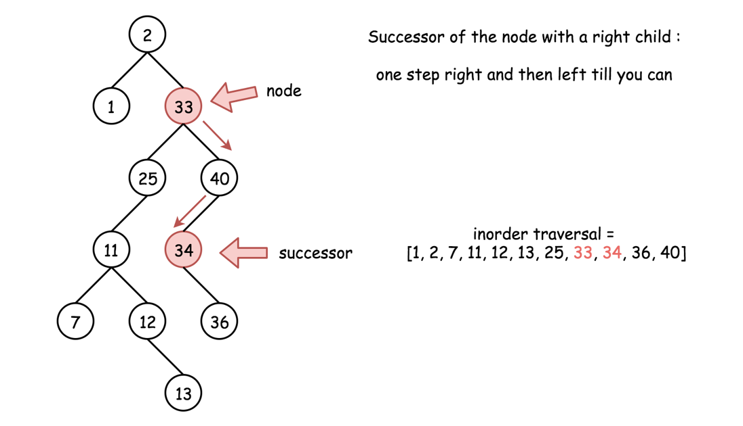

This approach has O(*Hp*​) time complexity, where *Hp*​ is a height of the node *p*.

Now let's consider the case 2. There is no access to the parent nodes here, and hence one has to traverse the tree starting from the root and not from the node.

[Inorder traversal could be implemented in three different ways: recursive, iterative and Morris](https://leetcode.com/articles/recover-binary-search-tree/). Here it's better to choose the iterative traversal in order to optimise the performance and minimize the space at the same time.

Iterative inorder traversal is simple: go left till you can, and then one step right. Repeat till the end of nodes in the tree.

The idea is to keep just one previous node during the inorder traversal. If that previous node is equal to p, then the current node is a successor of p.

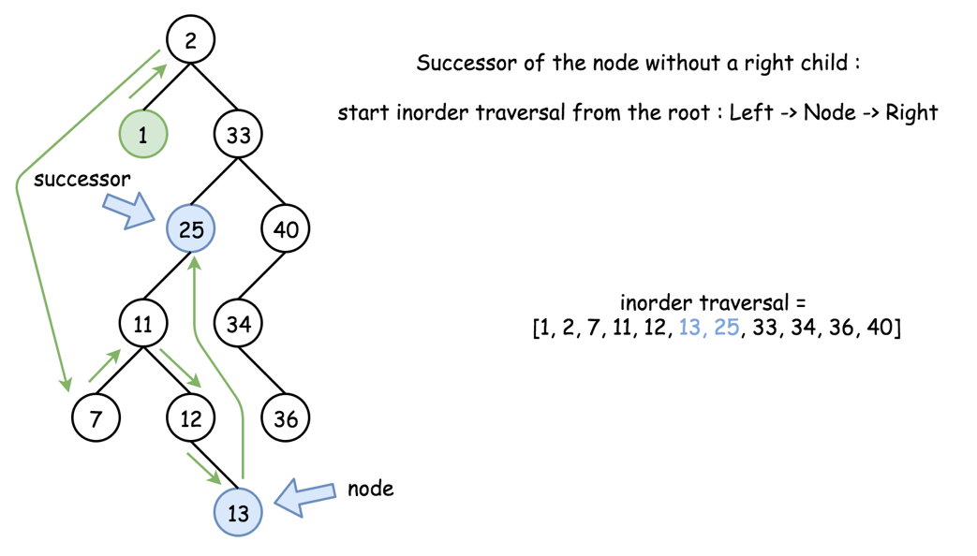

This approach has O(*H*) time complexity, where *H* is a tree height. Basically, this approach is universal and could be used for the case 1 as well. We simply don't do that because the approach 1 is faster.

**Algorithm**

* If the node has a right child, go one step right and then left till you can. Return the successor.
* Otherwise, implement iterative inorder traversal. While there are still nodes in the tree or in the stack:
  + Go left till you can, adding nodes in stack.
  + Pop out the last node. If its predecessor is equal to p, return that last node. Otherwise, save that node to be the predecessor in the next turn of the loop.
  + Go one step right.
* If we're here that means the successor doesn't exit. Return null.

|  |
| --- |
| class Solution {  public TreeNode inorderSuccessor(TreeNode root, TreeNode p) {  // the successor is somewhere lower in the right subtree  // successor: one step right and then left till you can  if (p.right != null) {  p = p.right;  while (p.left != null) p = p.left;  return p;  }  // the successor is somewhere upper in the tree  ArrayDeque<TreeNode> stack = new ArrayDeque<>();  int inorder = Integer.MIN_VALUE;  // inorder traversal : left -> node -> right  while (!stack.isEmpty() || root != null) {  // 1. go left till you can  while (root != null) {  stack.push(root);  root = root.left;  }  // 2. all logic around the node  root = stack.pop();  // if the previous node was equal to p  // then the current node is its successor  if (inorder == p.val) return root;  inorder = root.val;  // 3. go one step right  root = root.right;  }  // there is no successor  return null;  }  } |

**Complexity Analysis**

* Time complexity : O(*Hp*​) in the best case, when node p has a right child. Here *Hp*​ is a height of node p. O(*H*) in the worst case of no right child. Here *H* is a tree height.
* Space complexity : O(1) in the best case, when node p has a right child. Otherwise, up to O(*H*) to keep the stack.

**Binary Search Tree Iterator**

Implement the BSTIterator class that represents an iterator over the [**in-order traversal**](https://en.wikipedia.org/wiki/Tree_traversal#In-order_(LNR)) of a binary search tree (BST):

* BSTIterator(TreeNode root) Initializes an object of the BSTIterator class. The root of the BST is given as part of the constructor. The pointer should be initialized to a non-existent number smaller than any element in the BST.
* boolean hasNext() Returns true if there exists a number in the traversal to the right of the pointer, otherwise returns false.
* int next() Moves the pointer to the right, then returns the number at the pointer.

Notice that by initializing the pointer to a non-existent smallest number, the first call to next() will return the smallest element in the BST.

You may assume that next() calls will always be valid. That is, there will be at least a next number in the in-order traversal when next() is called.

**Example 1:**

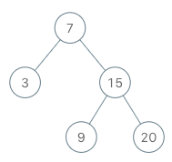

**Input**

["BSTIterator", "next", "next", "hasNext", "next", "hasNext", "next", "hasNext", "next", "hasNext"]

[[[7, 3, 15, null, null, 9, 20]], [], [], [], [], [], [], [], [], []]

**Output**

[null, 3, 7, true, 9, true, 15, true, 20, false]

**Explanation**

BSTIterator bSTIterator = new BSTIterator([7, 3, 15, null, null, 9, 20]);

bSTIterator.next(); // return 3

bSTIterator.next(); // return 7

bSTIterator.hasNext(); // return True

bSTIterator.next(); // return 9

bSTIterator.hasNext(); // return True

bSTIterator.next(); // return 15

bSTIterator.hasNext(); // return True

bSTIterator.next(); // return 20

bSTIterator.hasNext(); // return False

**Constraints:**

* The number of nodes in the tree is in the range [1, 105].
* 0 <= Node.val <= 106
* At most 105 calls will be made to hasNext, and next.

**Follow up:**

* Could you implement next() and hasNext() to run in average O(1) time and use O(h) memory, where h is the height of the tree?

## Solution

Before looking at the solutions for this problem, let's try and boil down what the problem statement essentially asks us to do. So, we need to implement an iterator class with two functions namely next() and hasNext(). The hasNext() function returns a boolean value indicating whether there are any more elements left in the binary search tree or not. The next() function returns the next smallest element in the BST. Therefore, the first time we call the next() function, it should return the smallest element in the BST and likewise, when we call next() for the very last time, it should return the largest element in the BST.

You might be wondering as to what could be the use case for an iterator. Essentially, an iterator can be used to iterate over any container object. For our purpose, the container object is a binary search tree. If such an iterator is defined, then the traversal logic can be abstracted out and we can simply make use of the iterator to process the elements in a certain order.

1. new_iterator = BSTIterator(root);

2. while (new_iterator.hasNext())

3. process(new_iterator.next());

Now that we know the motivation behind designing a good iterator class for a data structure, let's take a look at another interesting aspect about the iterator that we have to build for this problem. Usually, an iterator simply goes over each of the elements of the container one by one. For the BST, we want the iterator to return elements in an ascending order.

An important property of the binary search tree is that the inorder traversal of a BST gives us the elements in a sorted order. Thus, the inorder traversal will be the core of the solutions that we will look ahead.

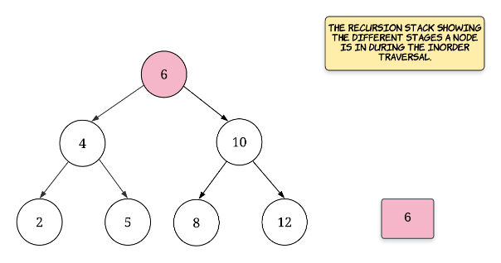

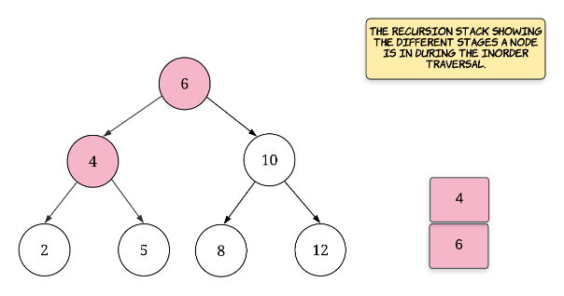

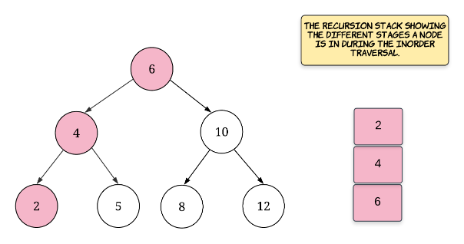

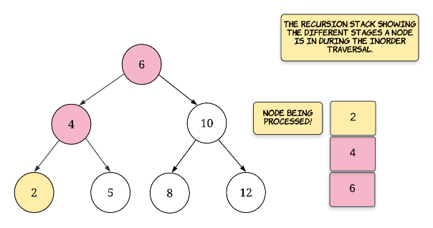

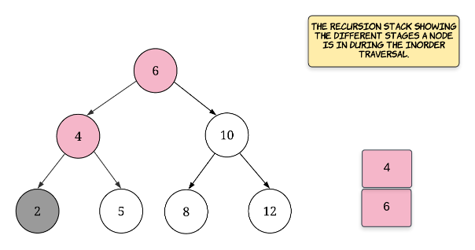

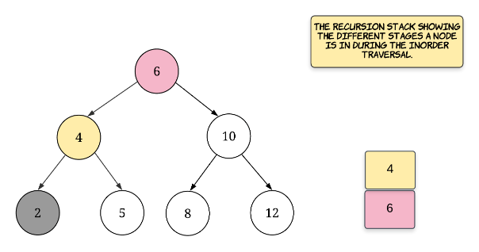

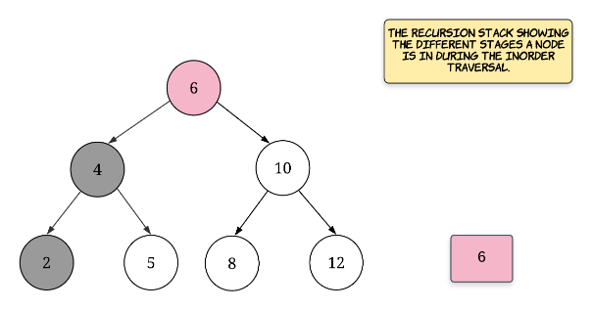

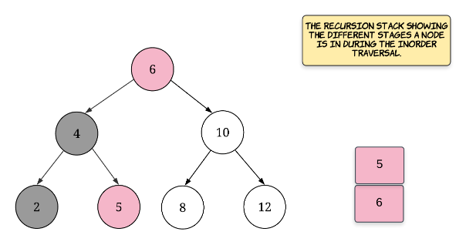

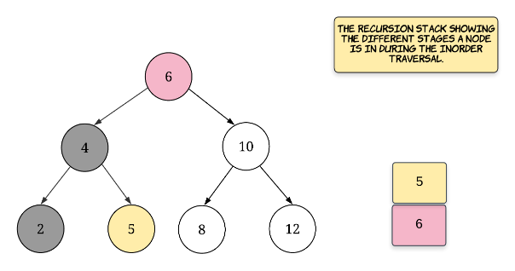

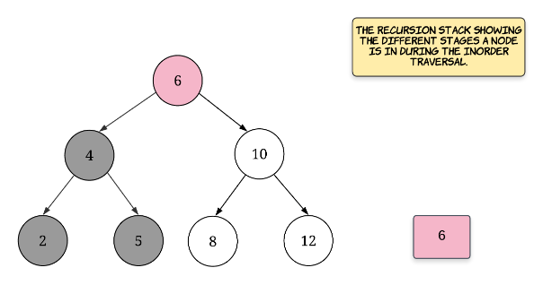

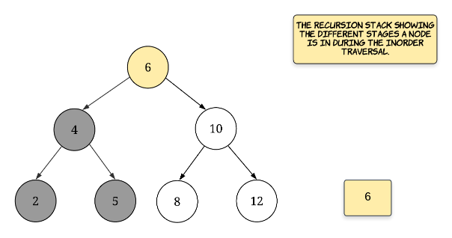

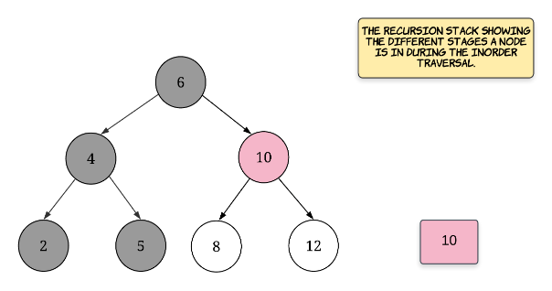

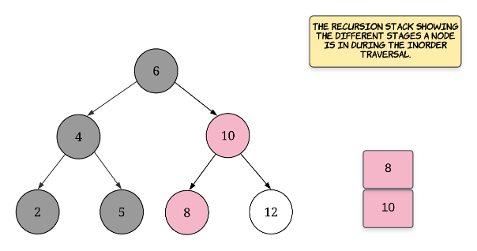

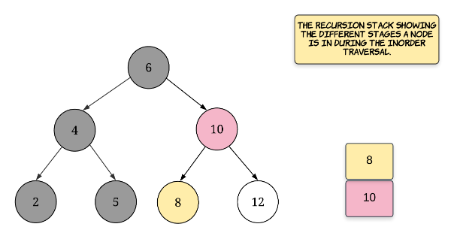

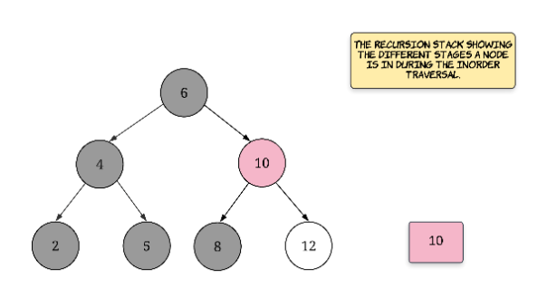

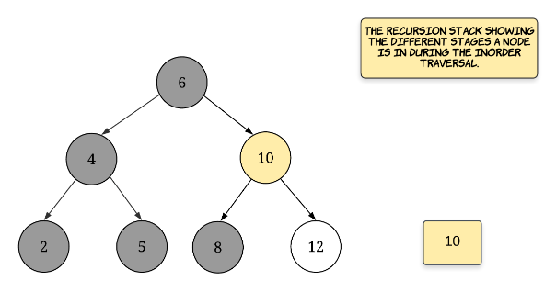

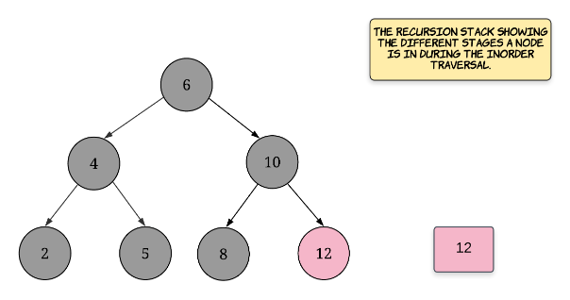

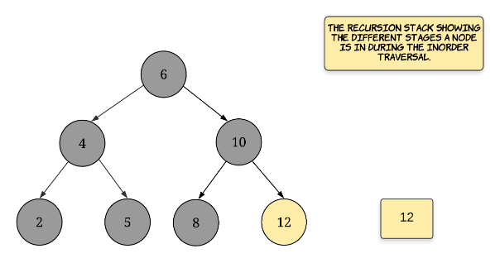

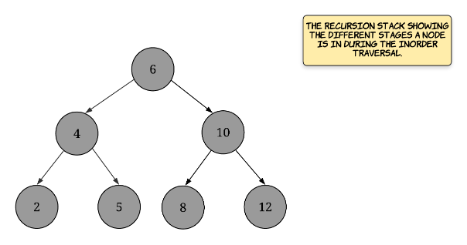

## Solution

Before looking at the solutions for this problem, let's try and boil down what the problem statement essentially asks us to do. So, we need to implement an iterator class with two functions namely next() and hasNext(). The hasNext() function returns a boolean value indicating whether there are any more elements left in the binary search tree or not. The next() function returns the next smallest element in the BST. Therefore, the first time we call the next() function, it should return the smallest element in the BST and likewise, when we call next() for the very last time, it should return the largest element in the BST.

You might be wondering as to what could be the use case for an iterator. Essentially, an iterator can be used to iterate over any container object. For our purpose, the container object is a binary search tree. If such an iterator is defined, then the traversal logic can be abstracted out and we can simply make use of the iterator to process the elements in a certain order.

1. new_iterator = BSTIterator(root);

2. while (new_iterator.hasNext())

3. process(new_iterator.next());

Now that we know the motivation behind designing a good iterator class for a data structure, let's take a look at another interesting aspect about the iterator that we have to build for this problem. Usually, an iterator simply goes over each of the elements of the container one by one. For the BST, we want the iterator to return elements in an ascending order.

An important property of the binary search tree is that the inorder traversal of a BST gives us the elements in a sorted order. Thus, the inorder traversal will be the core of the solutions that we will look ahead.



19 / 19

#### **Approach 1: Flattening the BST**

**Intuition**

In computer programming, an iterator is an object that enables a programmer to traverse a container, particularly lists. This is the Wikipedia definition of an iterator. Naturally, the easiest way to implement an iterator would be on an array like container interface. So, if we had an array, all we would need is a pointer or an index and we could easily implement the two required functions next() and hasNext().

Hence, the first approach that we will look at is based on this idea. We will be using additional memory and we will flatten the binary search tree into an array. Since we need the elements to be in a sorted order, we will do an inorder traversal over the tree and store the elements in a new array and then build the iterator functions using this new array.

**Algorithm**

1. Initialize an empty array that will contain the nodes of the binary search tree in the sorted order.
2. We traverse the binary search tree in the inorder fashion and for each node that we process, we add it to our array nodes. Note that before processing a node, its left subtree has to be processed (or recursed upon) and after processing a node, its right subtree has to be recursed upon.
3. Once we have all the nodes in an array, we simply need a pointer or an index in that array to implement the two functions next and hasNext. Whenever there's a call to hasNext, we simply check if the index has reached the end of the array or not. For the call to next function, we simply return the element pointed by the index. Also, after a the next function call is made, we have to move the index one step forward to simulate the progress of our iterator.

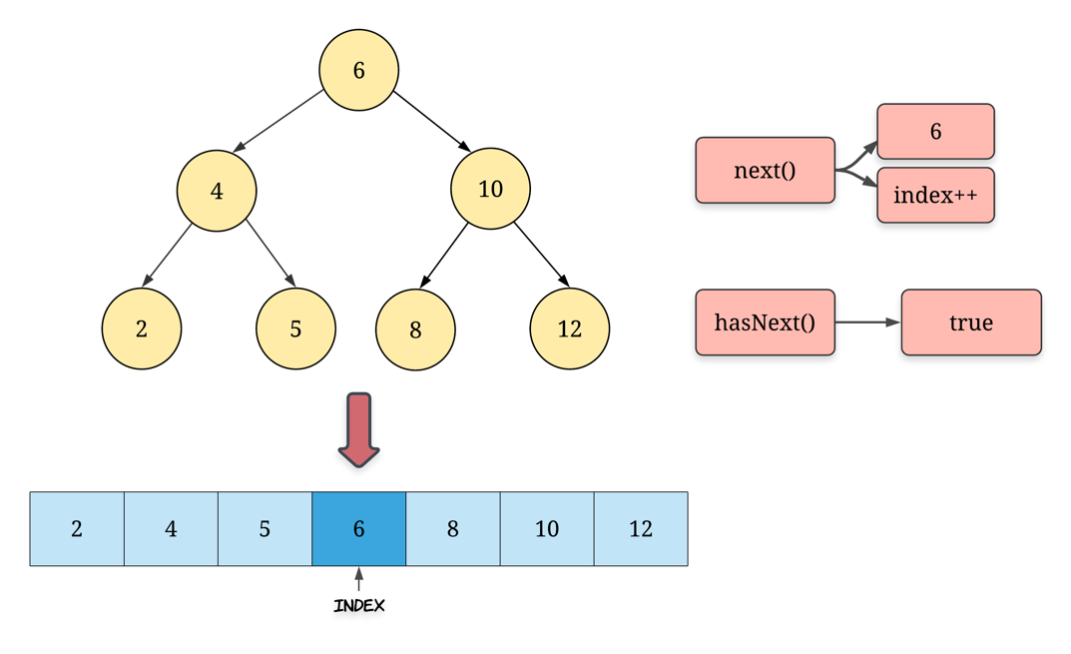

|  |
| --- |
| /**  * Definition for a binary tree node.  * public class TreeNode {  * int val;  * TreeNode left;  * TreeNode right;  * TreeNode(int x) { val = x; }  * }  */  class BSTIterator {  ArrayList<Integer> nodesSorted;  int index;  public BSTIterator(TreeNode root) {  // Array containing all the nodes in the sorted order  this.nodesSorted = new ArrayList<Integer>();  // Pointer to the next smallest element in the BST  this.index = -1;  // Call to flatten the input binary search tree  this._inorder(root);  }  private void _inorder(TreeNode root) {  if (root == null) {  return;  }  this._inorder(root.left);  this.nodesSorted.add(root.val);  this._inorder(root.right);  }  /**  * @return the next smallest number  */  public int next() {  return this.nodesSorted.get(++this.index);  }  /**  * @return whether we have a next smallest number  */  public boolean hasNext() {  return this.index + 1 < this.nodesSorted.size();  }  } |

**Complexity analysis**

* Time complexity : *O*(*N*) is the time taken by the constructor for the iterator. The problem statement only asks us to analyze the complexity of the two functions, however, when implementing a class, it's important to also note the time it takes to initialize a new object of the class and in this case it would be linear in terms of the number of nodes in the BST. In addition to the space occupied by the new array we initialized, the recursion stack for the inorder traversal also occupies space but that is limited to *O*(*h*) where *h* is the height of the tree.
  + next() would take *O*(1)
  + hasNext() would take *O*(1)
* Space complexity : *O*(*N*) since we create a new array to contain all the nodes of the BST. This doesn't comply with the requirement specified in the problem statement that the maximum space complexity of either of the functions should be *O*(*h*) where h*h* is the height of the tree and for a well balanced BST, the height is usually *logN*. So, we get great time complexities but we had to compromise on the space. Note that the new array is used for both the function calls and hence the space complexity for both the calls is *O*(*N*).

#### **Approach 2: Controlled Recursion**

**Intuition**

The approach we saw earlier uses space which is linear in the number of nodes in the binary search tree. However, the reason we had to resort to such an approach was because we can control the iteration over the array. We can't really pause a recursion in between and then start it off sometime later.

However, if we could simulate a controlled recursion for an inorder traversal, we wouldn't really need to use any additional space other than the space used by the stack for our recursion simulation.

So, this approach essentially uses a custom stack to simulate the inorder traversal i.e. we will be taking an iterative approach to inorder traversal rather than going with the recursive approach and in doing so, we will be able to easily implement the two function calls without any other additional space.

Things however, do get a bit complicated as far as the time complexity of the two operations is concerned and that is where we will spend a little bit of time to understand if this approach complies with all the asymptotic complexity requirements of the question. Let's move on to the algorithm for now to look at this idea more concretely.

**Algorithm**

1. Initialize an empty stack S which will be used to simulate the inorder traversal for our binary search tree. Note that we will be following the same approach for inorder traversal as before except that now we will be using our own stack rather than the system stack. Since we are using a custom data structure, we can pause and resume the recursion at will.
2. Let's also consider a helper function that we will be calling again and again in the implementation. This function, called _inorder_left will essentially add all the nodes in the leftmost branch of the tree rooted at the given node root to the stack and it will keep on doing so until there is no left child of the root node. Something like the following code:

|  |
| --- |
| def inorder_left(root):  while (root):  S.append(root)  root = root.left |

For a given node root, the next smallest element will always be the leftmost element in its tree. So, for a given root node, we keep on following the leftmost branch until we reach a node which doesn't have a left child and that will be the next smallest element. For the root of our BST, this leftmost node would be the smallest node in the tree. Rest of the nodes are added to the stack because they are pending processing. Try and relate this with a dry run of a simple recursive inorder traversal and things will make a bit more sense.

1. The first time next() function call is made, the smallest element of the BST has to be returned and then our simulated recursion has to move one step forward i.e. move onto the next smallest element in the BST. The invariant that will be maintained in this algorithm is that the stack top always contains the element to be returned for the next() function call. However, there is additional work that needs to be done to maintain that invariant. It's very easy to implement the hasNext() function since all we need to check is if the stack is empty or not. So, we will only focus on the next() call from now.
2. Initially, given the root node of the BST, we call the function _inorder_left and that ensures our invariant holds. Let's see this first step with an example.

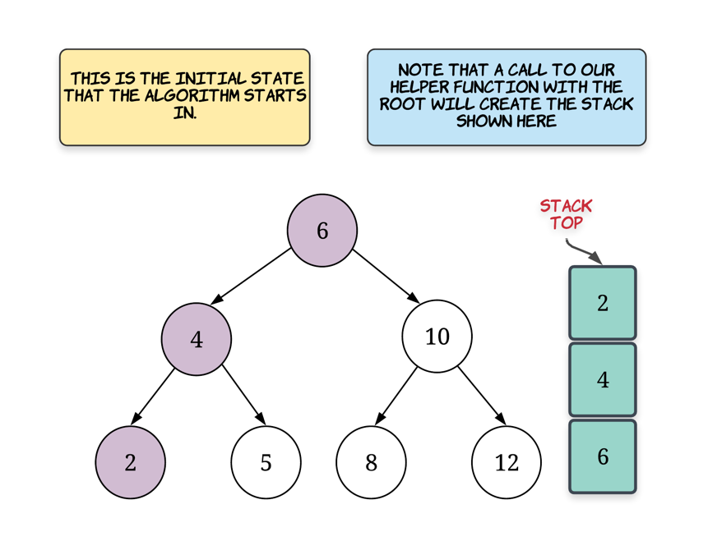

1. Suppose we get a call to the next() function. The node which we have to return i.e. the next smallest element in the binary search tree iterator is the one sitting at the top of our stack. So, for the example above, that node would be 2 which is the correct value. Now, there are two possibilities that we have to deal with:
   * One is where the node at the top of the stack is actually a leaf node. This is the best case and here we don't have to do anything. Simply pop the node off the stack and return its value. So, this would be a constant time operation.
   * Second is where the node has a right child. We don't need to check for the left child because of the way we have added nodes onto the stack. The topmost node either won't have a left child or would already have the left subtree processed. If it has a right child, then we call our helper function on the node's right child. This would comparatively be a costly operation depending upon the structure of the tree.

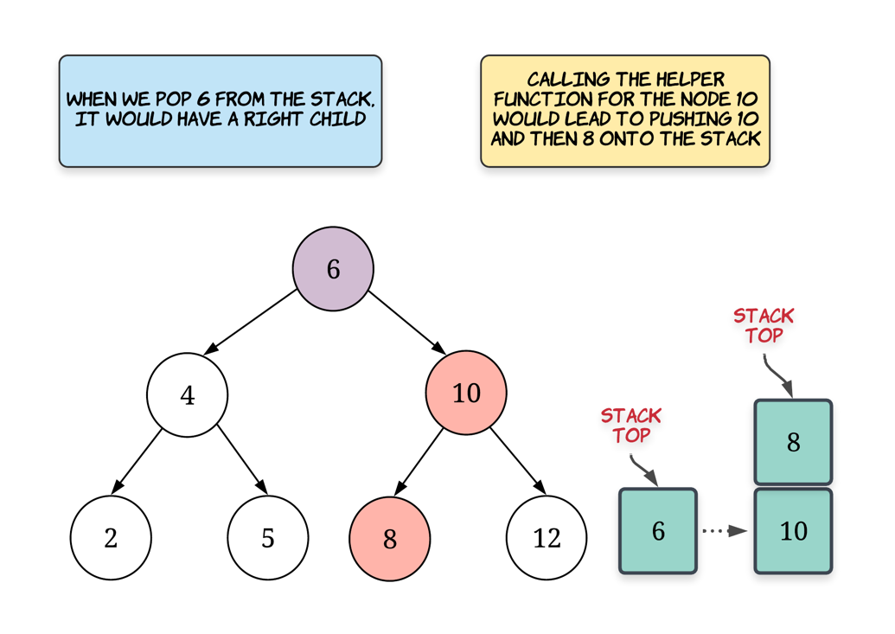

1. We keep on maintaining the invariant this way in the function call for next and this way we will always be able to return the next smallest element in the BST from the top of the stack. Again, it's important to understand that obtaining the next smallest element doesn't take much time. However, some time is spent in maintaining the invariant that the stack top will always have the node we are looking for.

|  |
| --- |
| /**  * Definition for a binary tree node.  * public class TreeNode {  * int val;  * TreeNode left;  * TreeNode right;  * TreeNode(int x) { val = x; }  * }  */  class BSTIterator {  Stack<TreeNode> stack;  public BSTIterator(TreeNode root) {  // Stack for the recursion simulation  this.stack = new Stack<TreeNode>();  // Remember that the algorithm starts with a call to the helper function  // with the root node as the input  this._leftmostInorder(root);  }  private void _leftmostInorder(TreeNode root) {  // For a given node, add all the elements in the leftmost branch of the tree  // under it to the stack.  while (root != null) {  this.stack.push(root);  root = root.left;  }  }  /**  * @return the next smallest number  */  public int next() {  // Node at the top of the stack is the next smallest element  TreeNode topmostNode = this.stack.pop();  // Need to maintain the invariant. If the node has a right child, call the  // helper function for the right child  if (topmostNode.right != null) {  this._leftmostInorder(topmostNode.right);  }  return topmostNode.val;  }  /**  * @return whether we have a next smallest number  */  public boolean hasNext() {  return this.stack.size() > 0;  }  } |

**Complexity analysis**

* Time complexity : The time complexity for this approach is very interesting to analyze. Let's look at the complexities for both the functions in the class:
  + hasNext is the easier of the lot since all we do in this is to return true if there are any elements left in the stack. Otherwise, we return false. So clearly, this is an *O*(1) operation every time. Let's look at the more complicated function now to see if we satisfy all the requirements in the problem statement
  + next involves two major operations. One is where we pop an element from the stack which becomes the next smallest element to return. This is a *O*(1) operation. However, we then make a call to our helper function _inorder_left which iterates over a bunch of nodes. This is clearly a linear time operation i.e. *O*(*N*) in the worst case. This is true.

However, the important thing to note here is that we only make such a call for nodes which have a right child. Otherwise, we simply return. Also, even if we end up calling the helper function, it won't always process N nodes. They will be much lesser. Only if we have a skewed tree would there be N nodes for the root. But that is the only node for which we would call the helper function.

Thus, the amortized (average) time complexity for this function would still be *O*(1) which is what the question asks for. We don't need to have a solution which gives constant time operations for *every* call. We need that complexity on average and that is what we get.

* Space complexity: The space complexity is *O*(*N*) (*N* is the number of nodes in the tree), which is occupied by our custom stack for simulating the inorder traversal. Again, we satisfy the space requirements as well as specified in the problem statement.

## Basic Operations in BST

In this chapter, we are going to introduce three basic operations in a BST.

After finishing this chapter, you should be able to:

1. Understand how to do search, insertion or deletion in a BST;
2. Implement search, insertion and deletion in a BST recursively and iteratively;
3. Understand the relationship among the number of the nodes, the height of the tree and the complexity of the operations.

**Search in a BST - Introduction**

BSTs support three main operations: search, insertion and deletion. In this section, we are going to talk about how to search for a specific value in a BST.

According to the property of BST, for each node:

1. return the node if the target value is ***equal to*** the value of the node;
2. continue searching in the ***left*** subtree if the target value is ***less than*** the value of the node;
3. continue searching in the ***right*** subtree if the target value is ***larger than*** the value of the node.

Let's go through an example: we search for ***target = 4*** in the BST above.

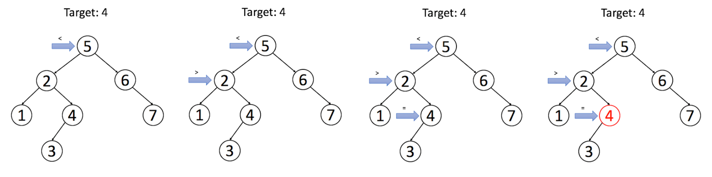

Please implement the search operation by yourself in our following exercise. You can do it recursively or iteratively. Try to analyze the time complexity and space complexity as well. We will provide a solution after that.

**Search in a Binary Search Tree**

You are given the root of a binary search tree (BST) and an integer val.

Find the node in the BST that the node's value equals val and return the subtree rooted with that node. If such a node does not exist, return null.

**Example 1:**

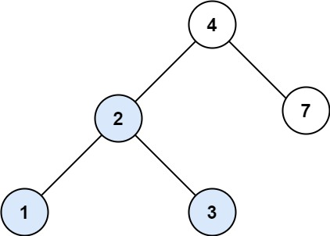

**Input:** root = [4,2,7,1,3], val = 2

**Output:** [2,1,3]

**Example 2:**

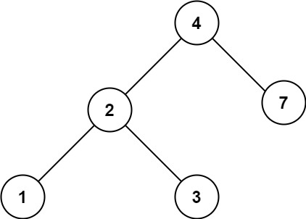

**Input:** root = [4,2,7,1,3], val = 5

**Output:** []

**Constraints:**

* The number of nodes in the tree is in the range [1, 5000].
* 1 <= Node.val <= 107
* root is a binary search tree.
* 1 <= val <= 107

## Solution

#### **Binary Search Tree.**

Binary Search Tree is a binary tree where the key in each node

* is greater than any key stored in the left sub-tree,
* and less than any key stored in the right sub-tree.

Here is an example:

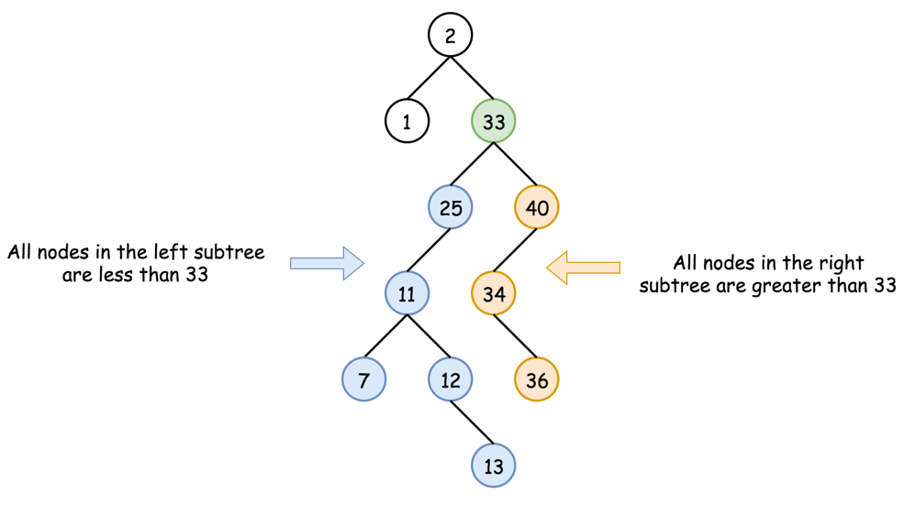

Such data structure provides the following operations in a logarithmic time:

* Search.
* [Insert](https://leetcode.com/articles/insert-into-a-bst/).
* [Delete](https://leetcode.com/articles/delete-node-in-a-bst/).

#### **Approach 1: Recursion**

**Algorithm**

The recursion implementation is very straightforward:

* If the tree is empty root == null or the value to find is here val == root.val - return root.
* If val < root.val - go to search into the left subtree searchBST(root.left, val).
* If val > root.val - go to search into the right subtree searchBST(root.right, val).
* Return root.

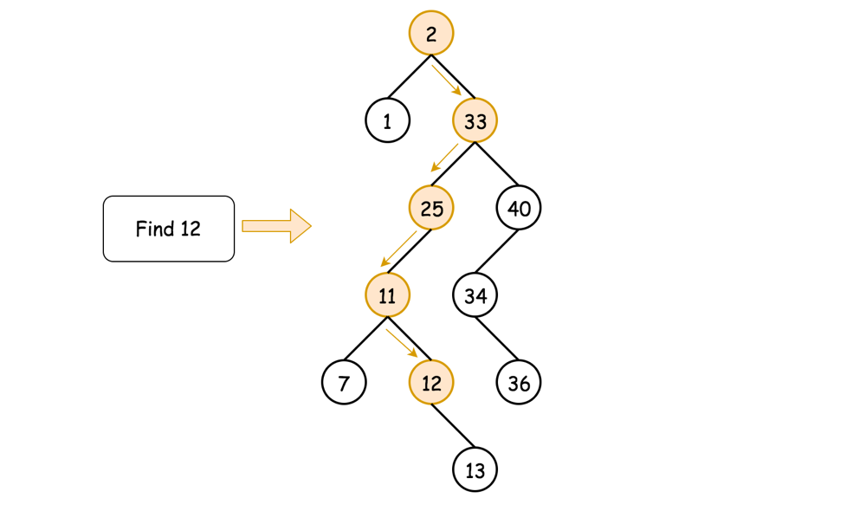

**Implementation**

|  |
| --- |
| class Solution {  public TreeNode searchBST(TreeNode root, int val) {  if (root == null || val == root.val) return root;  return val < root.val ? searchBST(root.left, val) : searchBST(root.right, val);  }  } |

**Complexity Analysis**

* Time complexity : O(*H*), where *H* is a tree height. That results in O(log*N*) in the average case, and O(*N*) in the worst case.

Let's compute time complexity with the help of [master theorem](https://en.wikipedia.org/wiki/Master_theorem_(analysis_of_algorithms)) 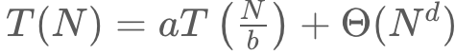. The equation represents dividing the problem up into a*a* subproblems of size 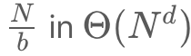 time. Here at step there is only one subproblem a = 1, its size is a half of the initial problem b = 2, and all this happens in a constant time d = 0, as for the binary search. That means that log*b*​*a*=*d* and hence we're dealing with [case 2](https://en.wikipedia.org/wiki/Master_theorem_(analysis_of_algorithms)#Case_2_example) that results in  time complexity.

* Space complexity : O(*H*) to keep the recursion stack, i.e. O(log*N*) in the average case, and O(*N*) in the worst case.

#### **Approach 2: Iteration**

To reduce the space complexity, one could convert recursive approach into the iterative one:

* While the tree is not empty root != null and the value to find is not here val != root.val:
  + If val < root.val - go to search into the left subtree root = root.left.
  + If val > root.val - go to search into the right subtree root = root.right.
* Return root.

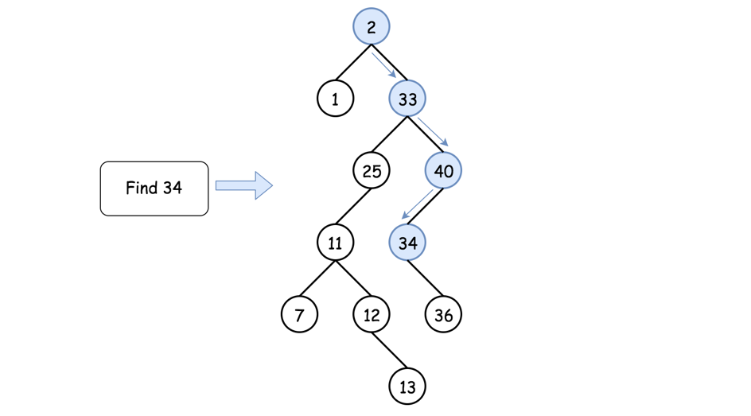

**Implementation**

|  |
| --- |
| class Solution {  public TreeNode searchBST(TreeNode root, int val) {  while (root != null && val != root.val)  root = val < root.val ? root.left : root.right;  return root;  }  } |

**Complexity Analysis**

* Time complexity : O(*H*), where *H* is a tree height. That results in O(log*N*) in the average case, and O(*N*) in the worst case.

Let's compute time complexity with the help of [master theorem](https://en.wikipedia.org/wiki/Master_theorem_(analysis_of_algorithms)) . The equation represents dividing the problem up into *a* subproblems of size  time. Here at step there is only one subproblem a = 1, its size is a half of the initial problem b = 2, and all this happens in a constant time d = 0, as for the binary search. That means that log*b*​*a*=*d* and hence we're dealing with [case 2](https://en.wikipedia.org/wiki/Master_theorem_(analysis_of_algorithms)#Case_2_example) that results in  time complexity.

* Space complexity : O(1) since it's a constant space solution.

**Search in a BST - Solution**

We provide the recursive and iterative solution for your reference.

Here is a recursive solution:

|  |
| --- |
| /**  * Definition for a binary tree node.  * public class TreeNode {  * int val;  * TreeNode left;  * TreeNode right;  * TreeNode(int x) { val = x; }  * }  */  class Solution {  public TreeNode searchBST(TreeNode root, int target) {  if (root == null || root.val == target) {  return root;  }  if (target < root.val) {  return searchBST(root.left, target);  }  return searchBST(root.right, target);  }  } |

We can also solve this problem iteratively:

|  |
| --- |
| /**  * Definition for a binary tree node.  * public class TreeNode {  * int val;  * TreeNode left;  * TreeNode right;  * TreeNode(int x) { val = x; }  * }  */  class Solution {  public TreeNode searchBST(TreeNode root, int target) {  TreeNode cur = root;  while (cur != null && cur.val != target) {  if (target < cur.val) {  cur = cur.left;  } else {  cur = cur.right;  }  }  return cur;  }  } |

Let's discuss the time complexity and space complexity of the search operation in a BST whose height is h. Focus on the recursion solution first. In the worse case, the depth of our recursion is equal to the height of the tree. Therefore, the time complexity of the recursion solution is O(h). And taking system stack into consideration, the space complexity should be O(h) in the worst case as well.

What about the iterative solution? The time complexity will be equal to the loop time which is also O(h) while the space complexity is O(1) since we do not need system stack anymore in an iterative solution.

 Question:

If you do not know the height of the BST h but you are given the total number of nodes N of the BST, can you express the time complexity and space complexity using N instead of h?

Hint:

What's the difference of the relationship between N and h in the best case and the relationship in the worst case?

**Insertion in a Binary Search Tree - Introduction**

Another common operation in BST is to insert a new node. There are many different strategies for insertion. We only talk about a typical insertion strategy which minimizes the changes. The main idea is to find out a proper leaf position for the target node and then insert the node as a leaf. Therefore, insertion will begin as a search.

Similar to our search strategy, for each node, we will:

1. search the left or right subtrees according to the relation of the value of the node and the value of our target node;
2. repeat STEP 1 until reaching an external node;
3. add the new node as its left or right child depending on the relation of the value of the node and the value of our target node.

In this way, we add a new node and maintain the property of BST.

Let's go through an example:

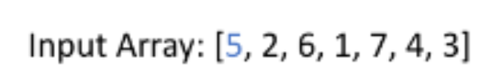

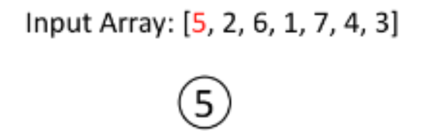

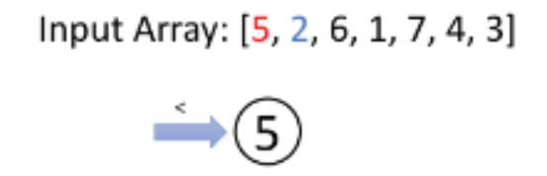

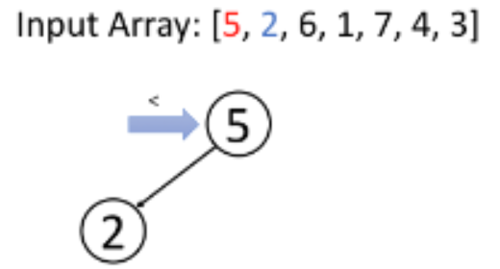

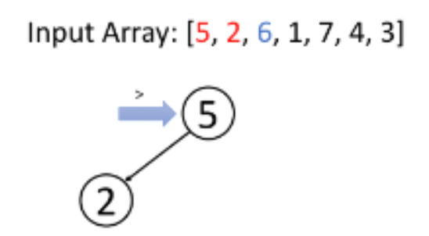

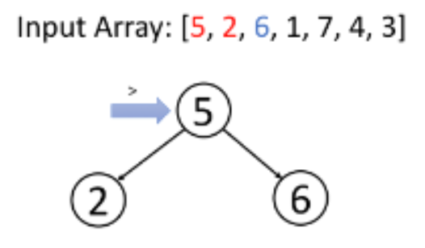

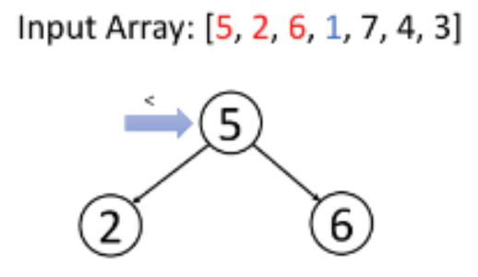

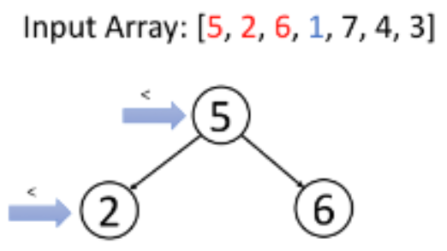

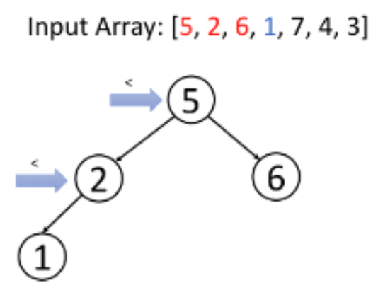

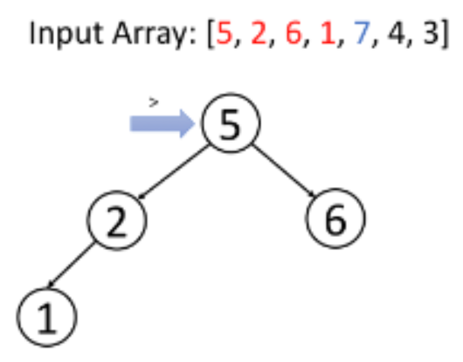

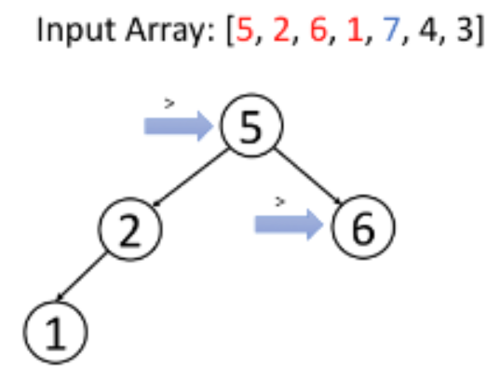

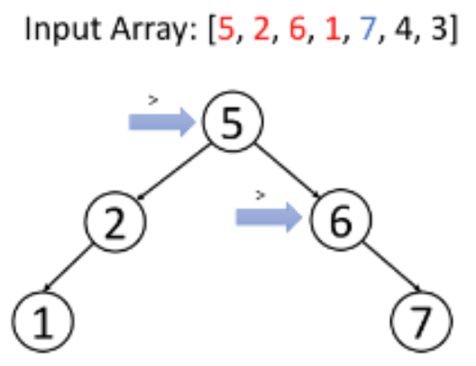

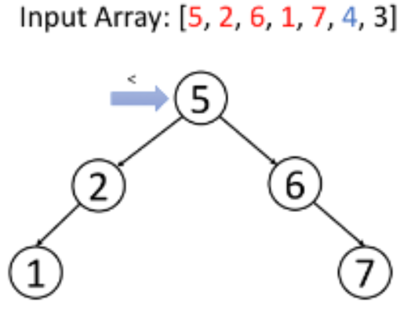

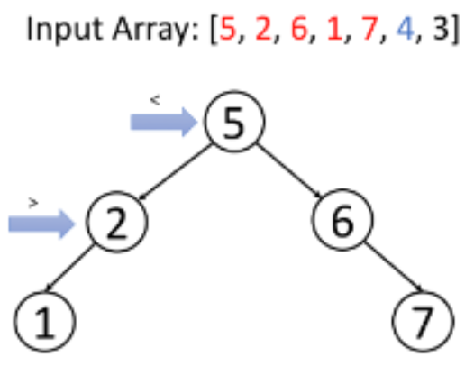

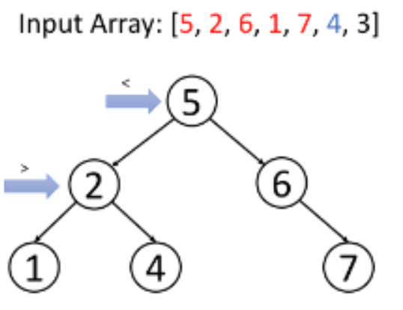

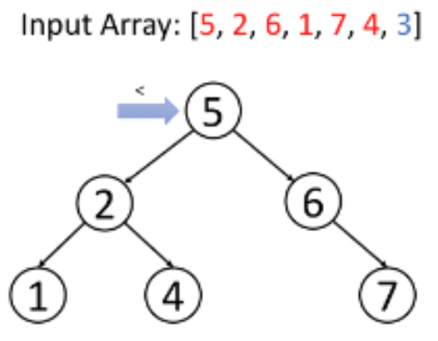

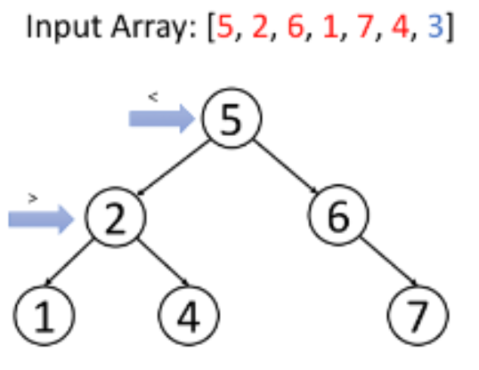

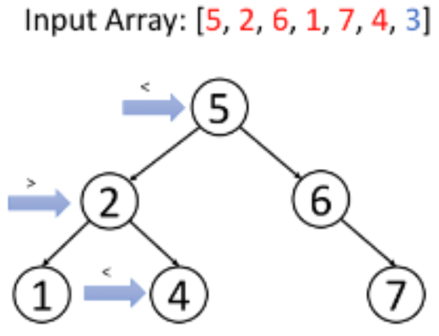

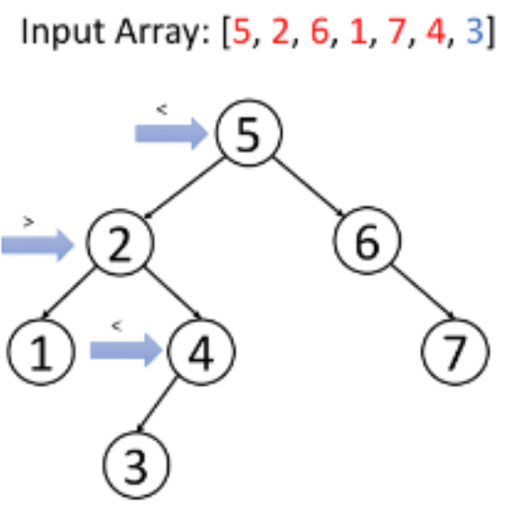

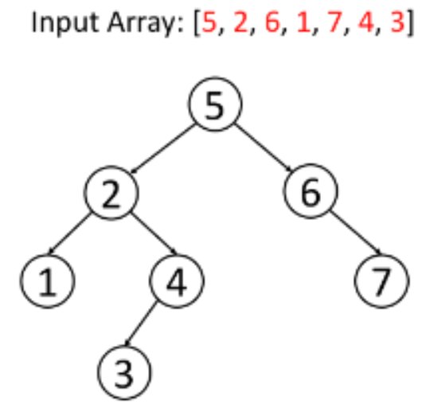  
  
Similar to search, we can do insertion recursively or iteratively. The solution is so similar with search that you should be able to implement it by yourself and analyze the time complexity and space complexity in the same way.

**Insert into a Binary Search Tree**

You are given the root node of a binary search tree (BST) and a value to insert into the tree. Return *the root node of the BST after the insertion*. It is **guaranteed** that the new value does not exist in the original BST.

**Notice** that there may exist multiple valid ways for the insertion, as long as the tree remains a BST after insertion. You can return **any of them**.

**Example 1:**

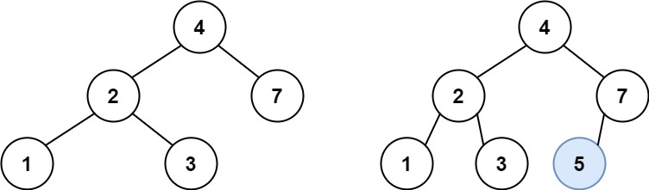

**Input:** root = [4,2,7,1,3], val = 5

**Output:** [4,2,7,1,3,5]

**Explanation:** Another accepted tree is:

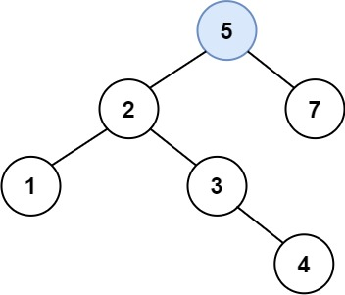

**Example 2:**

**Input:** root = [40,20,60,10,30,50,70], val = 25

**Output:** [40,20,60,10,30,50,70,null,null,25]

**Example 3:**

**Input:** root = [4,2,7,1,3,null,null,null,null,null,null], val = 5

**Output:** [4,2,7,1,3,5]

**Constraints:**

* The number of nodes in the tree will be in the range [0, 104].
* -108 <= Node.val <= 108
* All the values Node.val are **unique**.
* -108 <= val <= 108
* It's **guaranteed** that val does not exist in the original BST.

## Solution

#### **Intuition**

One of the huge BST advantages is a [search](https://leetcode.com/problems/search-in-a-binary-search-tree/) for arbitrary element in O(log*N*) time. Here we'll see that the insert time is O(log*N*), too, in the average case.

The problem solution is very simple - one could always insert new node as a child of the leaf. To define which leaf to use, one could follow the standard BST logic :

* If val > node.val - go to insert into the right subtree.
* If val < node.val - go to insert into the left subtree.

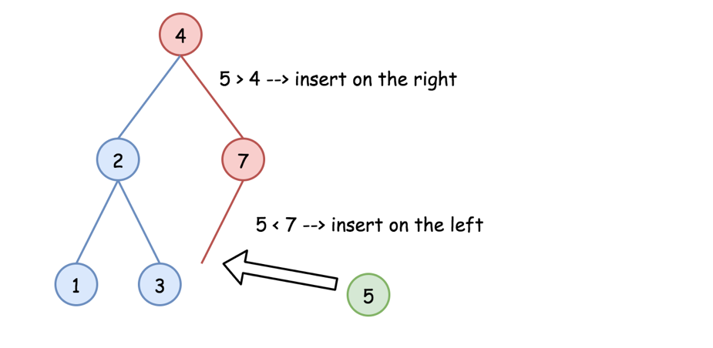

#### **Approach 1: Recursion**

The recursion implementation is very straightforward :

* If root is null - return TreeNode(val).
* If val > root.val - go to insert into the right subtree.
* If val < root.val - go to insert into the left subtree.
* Return root.

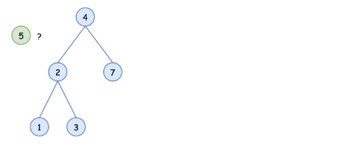

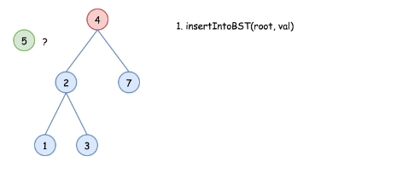

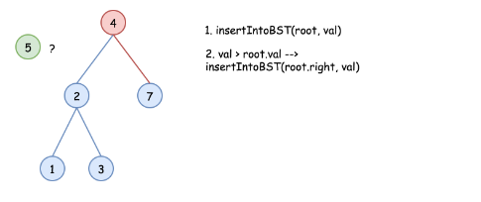

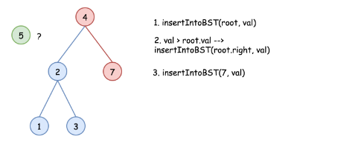

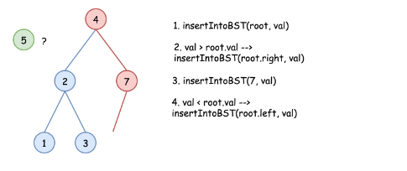

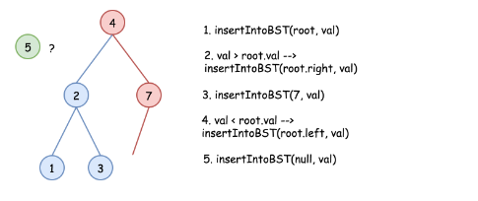

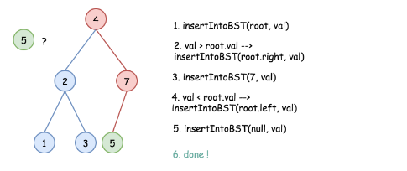

|  |
| --- |
| class Solution {  public TreeNode insertIntoBST(TreeNode root, int val) {  if (root == null) return new TreeNode(val);  // insert into the right subtree  if (val > root.val) root.right = insertIntoBST(root.right, val);  // insert into the left subtree  else root.left = insertIntoBST(root.left, val);  return root;  }  } |

**Complexity Analysis**

* Time complexity : O(*H*), where *H* is a tree height. That results in O(log*N*) in the average case, and O(*N*) in the worst case.

Let's compute time complexity with the help of [master theorem](https://en.wikipedia.org/wiki/Master_theorem_(analysis_of_algorithms)) . The equation represents dividing the problem up into *a* subproblems of size  time. Here at step there is only one subproblem a = 1, its size is a half of the initial problem b = 2, and all this happens in a constant time d = 0, as for the binary search. That means that log*b*​*a*=*d* and hence we're dealing with [case 2](https://en.wikipedia.org/wiki/Master_theorem_(analysis_of_algorithms)#Case_2_example) that results in  time complexity.

* Space complexity : O(*H*) to keep the recursion stack, i.e.  O(log*N*) in the average case, and O(*N*) in the worst case.

#### **Approach 2: Iteration**

The recursion above could be converted into the iteration

|  |
| --- |
| class Solution {  public TreeNode insertIntoBST(TreeNode root, int val) {  TreeNode node = root;  while (node != null) {  // insert into the right subtree  if (val > node.val) {  // insert right now  if (node.right == null) {  node.right = new TreeNode(val);  return root;  }  else node = node.right;  }  // insert into the left subtree  else {  // insert right now  if (node.left == null) {  node.left = new TreeNode(val);  return root;  }  else node = node.left;  }  }  return new TreeNode(val);  }  } |

**Complexity Analysis**

* Time complexity : O(*H*), where H*H* is a tree height. That results in O(log*N*) in the average case, and O(*N*) in the worst case.

Let's compute time complexity with the help of [master theorem](https://en.wikipedia.org/wiki/Master_theorem_(analysis_of_algorithms)) . The equation represents dividing the problem up into a*a* subproblems of size  time. Here at step there is only one subproblem a = 1, its size is a half of the initial problem b = 2, and all this happens in a constant time d = 0, as for the binary search. That means that log*b*​*a*=*d* and hence we're dealing with [case 2](https://en.wikipedia.org/wiki/Master_theorem_(analysis_of_algorithms)#Case_2_example) that results in  time complexity.

* Space complexity : O(1) since it's a constant space solution.

**Insertion in a BST - Solution**

Insertion in a BST is quite similar with search in a BST. Here we only provide recursive solution in Java and C++ for your reference.

|  |
| --- |
| /**  * Definition for a binary tree node.  * public class TreeNode {  * int val;  * TreeNode left;  * TreeNode right;  * TreeNode(int x) { val = x; }  * }  */  class Solution {  public TreeNode insertIntoBST(TreeNode root, int val) {  if (root == null) {  return new TreeNode(val); // return a new node if root is null  }  if (root.val < val) { // insert to the right subtree if val > root->val  root.right = insertIntoBST(root.right, val);  } else { // insert to the left subtree if val <= root->val  root.left = insertIntoBST(root.left, val);  }  return root;  }  } |

The time complexity of the insertion operation is the same with search operation which is O(h). Or O(N) in the worst case and O(logN) ideally if the tree is well organized.

The space complexity of the recursion soultion is O(h) as well. In other word, O(N) in the worst case and O(logN) ideally. If you implement the algorithm iteratively, the space complexity can be O(1).

**Deletion in a BST - Introduction**

Deletion is more complicated than the two operations we mentioned before. There are also many different strategies for deletion. We are going to introduce one of them which minimizes the changes. Our solution is to replace the target node with a proper child. According to the number of its children, we should consider three different cases:

1. If the target node has ***no child***, we can simply remove the node.  
2. If the target node has ***one child***, we can use its child to replace itself.  
3. If the target node has ***two children***, replace the node with its in-order successor or predecessor node and delete that node.

Here are examples of different cases to help you understand this strategy.

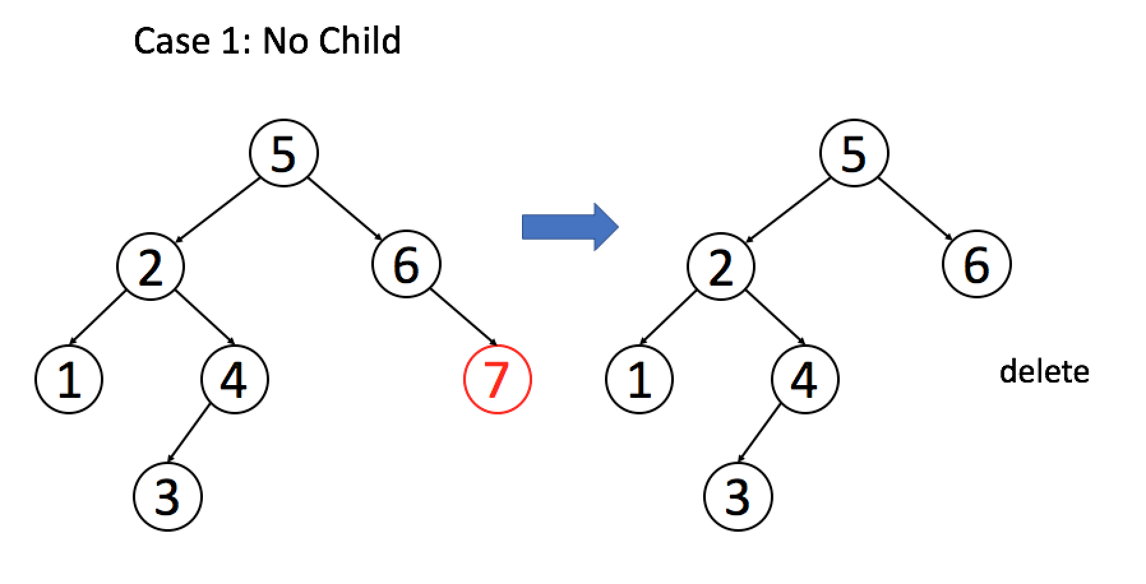

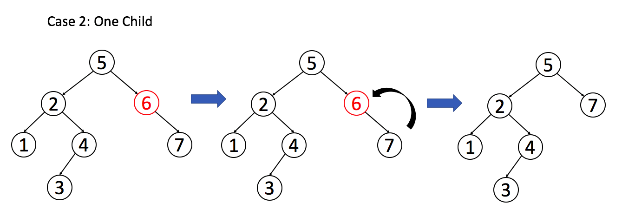  
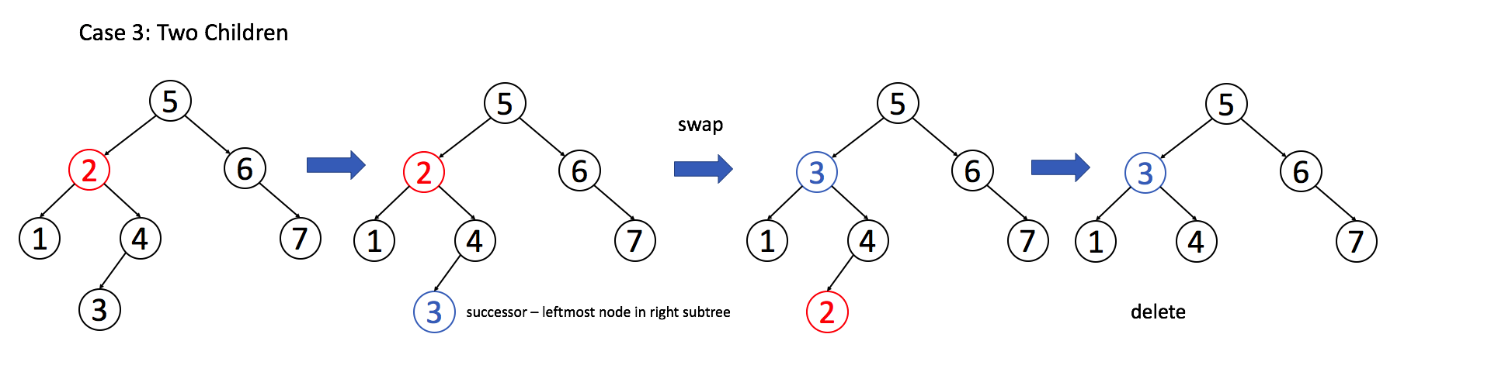

By understanding the strategy above, you should be able to implement deletion function on your own. We have done an exercise about finding the inorder successor in a BST in the previous section. The solution for that question might help you implement the deletion function.

**Delete Node in a BST**

Given a root node reference of a BST and a key, delete the node with the given key in the BST. Return the root node reference (possibly updated) of the BST.

Basically, the deletion can be divided into two stages:

1. Search for a node to remove.
2. If the node is found, delete the node.

**Follow up:** Can you solve it with time complexity O(height of tree)?

**Example 1:**

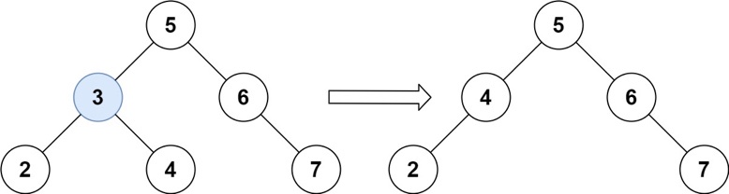

**Input:** root = [5,3,6,2,4,null,7], key = 3

**Output:** [5,4,6,2,null,null,7]

**Explanation:** Given key to delete is 3. So we find the node with value 3 and delete it.

One valid answer is [5,4,6,2,null,null,7], shown in the above BST.

Please notice that another valid answer is [5,2,6,null,4,null,7] and it's also accepted.

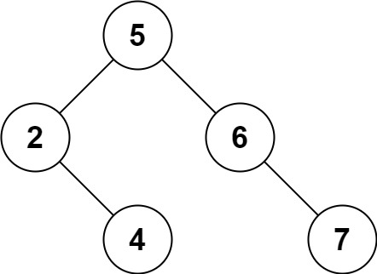

**Example 2:**

**Input:** root = [5,3,6,2,4,null,7], key = 0

**Output:** [5,3,6,2,4,null,7]

**Explanation:** The tree does not contain a node with value = 0.

**Example 3:**

**Input:** root = [], key = 0

**Output:** []

**Constraints:**

* The number of nodes in the tree is in the range [0, 104].
* -105 <= Node.val <= 105
* Each node has a **unique** value.
* root is a valid binary search tree.
* -105 <= key <= 105

## Solution

#### **Three facts to know about BST**

Here is list of facts which are better to know before the interview.

Inorder traversal of BST is an array sorted in the ascending order.

To compute inorder traversal follow the direction Left -> Node -> Right.

|  |
| --- |
| public LinkedList<Integer> inorder(TreeNode root, LinkedList<Integer> arr) {  if (root == null) return arr;  inorder(root.left, arr);  arr.add(root.val);  inorder(root.right, arr);  return arr;  } |

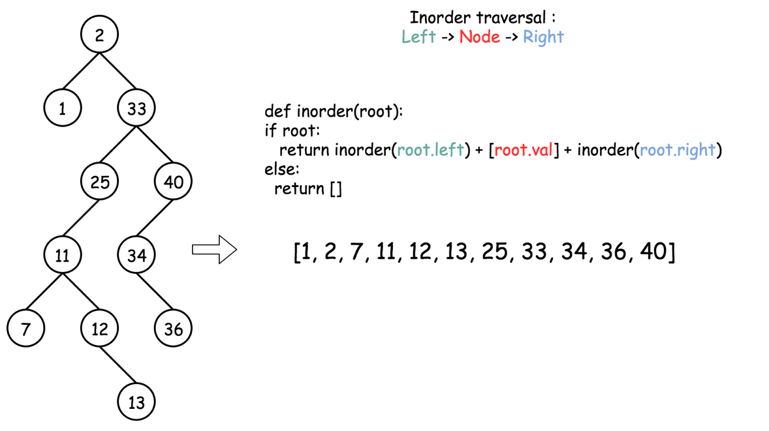

Successor = "after node", i.e. the next node, or the smallest node *after* the current one.

It's also the *next* node in the inorder traversal. To find a successor, go to the right once and then as many times to the left as you could.

|  |
| --- |
| public int successor(TreeNode root) {  root = root.right;  while (root.left != null) root = root.left;  return root;  } |

Predecessor = "before node", i.e. the previous node, or the largest node *before* the current one.

It's also the *previous* node in the inorder traversal. To find a predecessor, go to the left once and then as many times to the right as you could.

|  |
| --- |
| public int predecessor(TreeNode root) {  root = root.left;  while (root.right != null) root = root.right;  return root;  } |

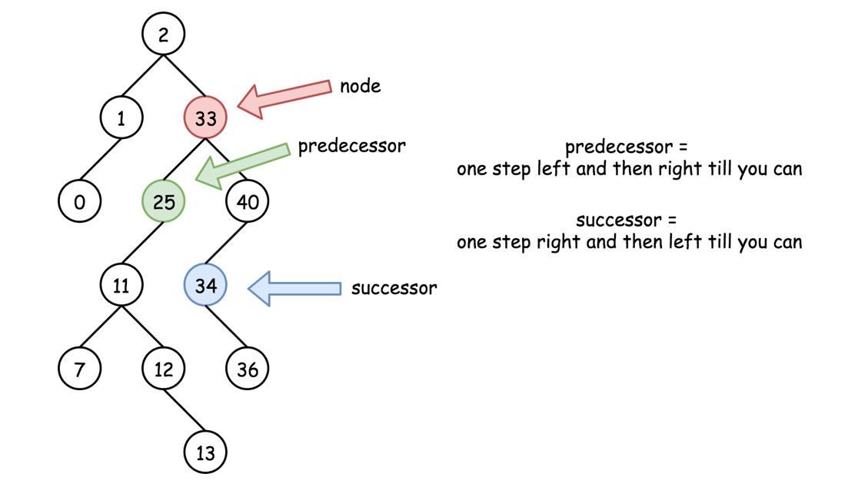

#### **Approach 1: Recursion**

**Intuition**

There are three possible situations here :

* Node is a leaf, and one could delete it straightforward : node = null.

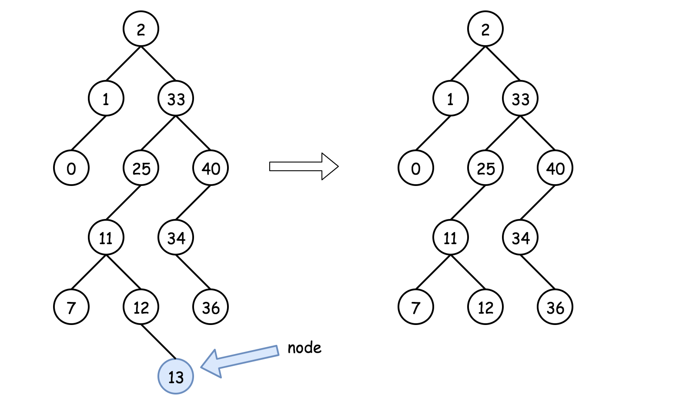

* Node is not a leaf and has a right child. Then the node could be replaced by its successor which is somewhere lower in the right subtree. Then one could proceed down recursively to delete the successor.

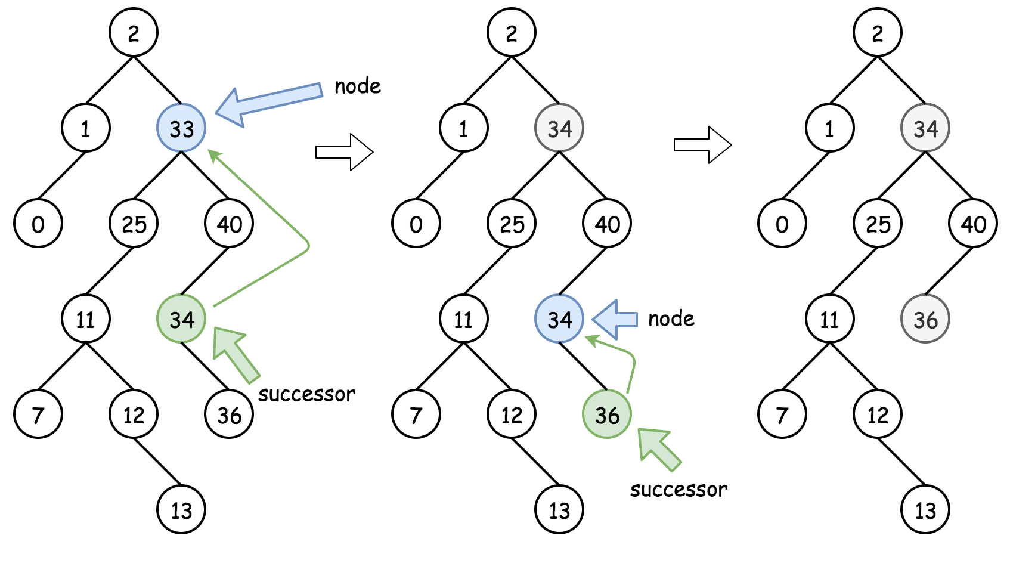

* Node is not a leaf, has no right child and has a left child. That means that its successor is somewhere upper in the tree but we don't want to go back. Let's use the predecessor here which is somewhere lower in the left subtree. The node could be replaced by its predecessor and then one could proceed down recursively to delete the predecessor.

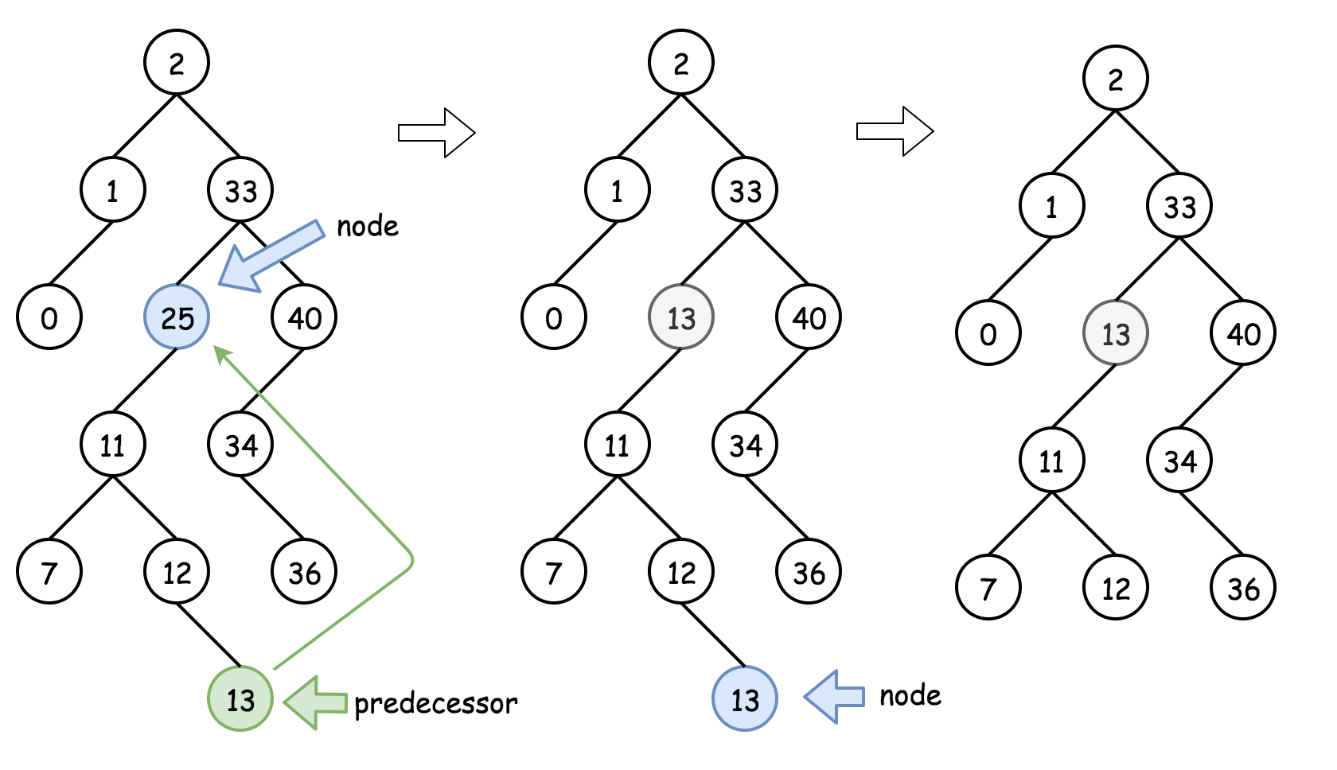

**Algorithm**

* If key > root.val then delete the node to delete is in the right subtree root.right = deleteNode(root.right, key).
* If key < root.val then delete the node to delete is in the left subtree root.left = deleteNode(root.left, key).
* If key == root.val then the node to delete is right here. Let's do it :
  + If the node is a leaf, the delete process is straightforward : root = null.
  + If the node is not a leaf and has the right child, then replace the node value by a successor value root.val = successor.val, and then recursively delete the successor in the right subtree root.right = deleteNode(root.right, root.val).
  + If the node is not a leaf and has only the left child, then replace the node value by a predecessor value root.val = predecessor.val, and then recursively delete the predecessor in the left subtree root.left = deleteNode(root.left, root.val).
* Return root.

**Implementation**

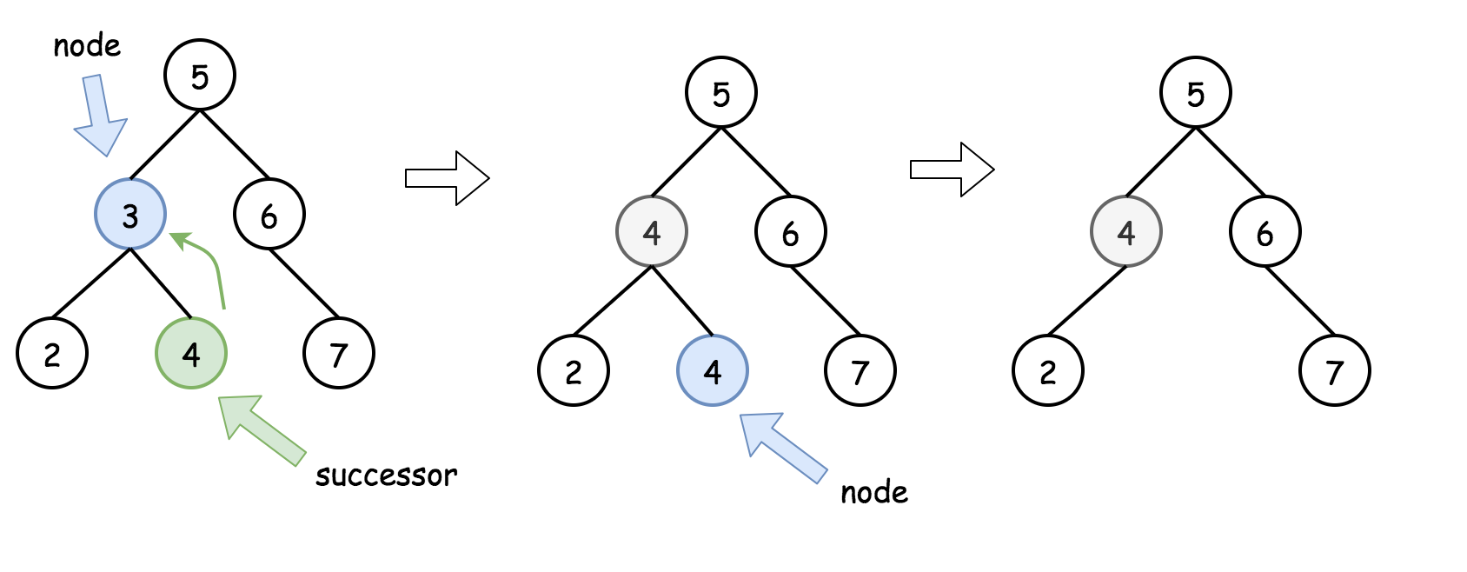

|  |
| --- |
| class Solution {  /*  One step right and then always left  */  public int successor(TreeNode root) {  root = root.right;  while (root.left != null) root = root.left;  return root.val;  }  /*  One step left and then always right  */  public int predecessor(TreeNode root) {  root = root.left;  while (root.right != null) root = root.right;  return root.val;  }  public TreeNode deleteNode(TreeNode root, int key) {  if (root == null) return null;  // delete from the right subtree  if (key > root.val) root.right = deleteNode(root.right, key);  // delete from the left subtree  else if (key < root.val) root.left = deleteNode(root.left, key);  // delete the current node  else {  // the node is a leaf  if (root.left == null && root.right == null) root = null;  // the node is not a leaf and has a right child  else if (root.right != null) {  root.val = successor(root);  root.right = deleteNode(root.right, root.val);  }  // the node is not a leaf, has no right child, and has a left child  else {  root.val = predecessor(root);  root.left = deleteNode(root.left, root.val);  }  }  return root;  }  } |

**Complexity Analysis**

* Time complexity : O(log*N*). During the algorithm execution we go down the tree all the time - on the left or on the right, first to search the node to delete O(*H*1​) time complexity as already [discussed](https://leetcode.com/articles/insert-into-a-bst/)) and then to actually delete it. *H*1​ is a tree height from the root to the node to delete. Delete process takes O(*H*2​) time, where *H*2​ is a tree height from the root to delete to the leafs. That in total results in O(*H*1​+*H*2​)=O(*H*) time complexity, where *H* is a tree height, equal to \log Nlog*N* in the case of the balanced tree.
* Space complexity : O(*H*) to keep the recursion stack, where *H* is a tree height. H=log*N* for the balanced tree.

**Deletion in a BST - Solution**

Deletion operation is a little more complicated. we also provide c++ and java codes for your reference.

|  |
| --- |
| /**  * Definition for a binary tree node.  * public class TreeNode {  * int val;  * TreeNode left;  * TreeNode right;  * TreeNode(int x) { val = x; }  * }  */  class Solution {  /**  * findSuccesor - Helper function for finding successor  * In BST, succesor of root is the leftmost child in root's right subtree  */  private TreeNode findSuccessor(TreeNode root) {  TreeNode cur = root.right;  while (cur != null && cur.left != null) {  cur = cur.left;  }  return cur;  }  public TreeNode deleteNode(TreeNode root, int key) {  // return null if root is null  if (root == null) {  return root;  }  // delete current node if root is the target node  if (root.val == key) {  // replace root with root->right if root->left is null  if (root.left == null) {  return root.right;  }  // replace root with root->left if root->right is null  if (root.right == null) {  return root.left;  }  // replace root with its successor if root has two children  TreeNode p = findSuccessor(root);  root.val = p.val;  root.right = deleteNode(root.right, p.val);  return root;  }  if (root.val < key) {  // find target in right subtree if root->val < key  root.right = deleteNode(root.right, key);  } else {  // find target in left subtree if root->val > key  root.left = deleteNode(root.left, key);  }  return root;  }  } |

We are going to discuss the time complexity and the space complexity as usual.

For the implementation above, similar to the recursion solution of the search operation, the time complexity is O(h) in the worst case. And according to the depth of recursion, the space complexity is also O(h) in the worst case.

We can also represent the complexity using the total number of nodes N. The time complexity and space complexity will be O(logN) in the best case but O(N) in the worse case.

If you can try to implement the strategy iteratively, you will reduce the space complexity to O(1).

## Conclusion

After finishing the previous chapters, you should be familiar with the properties of a BST.

In this chapter, we are going to apply the BST to real problems. We will discuss an example together and then provide some exercise for you.

**Introduction to Binary Search Tree - Conclusion**

* [An Example](https://leetcode.com/explore/learn/card/introduction-to-data-structure-binary-search-tree/142/conclusion/1009/#an-example)
  + [1. Insertion](https://leetcode.com/explore/learn/card/introduction-to-data-structure-binary-search-tree/142/conclusion/1009/#1-insertion)
  + [2. Search](https://leetcode.com/explore/learn/card/introduction-to-data-structure-binary-search-tree/142/conclusion/1009/#2-search)

We have introduced the properties of a BST and how to perform the basic operations, including search, insertion and deletion, in a BST. Being familiar with these basic ideas, you will be able to apply a BST to solve a real problem.

The strength of a BST is that you can perform all search, insertion and deletion operations in O(h) time complexity even in the worst case.

Usually, if you want to store data in order and need several operations, such as search, insertion or deletion, at the same time, a BST might be a good choice.

### **An Example**

Problem: Design a class to find the kth largest element in a stream.

A most obvious way to solve this problem is to sort the array in descending order first and then return the kth element in the array.

But we have to sort for the new element everytime when we insert a new value in order to perform the search operation in O(1) time complexity. But the time complexity of the insertion operation will be O(N) in average. Therefore, time complexity will be O(N^2) in total.

Since we need insertion and search operations at the same time, what about using a BST to store the values?

As we know, for each node in a BST, all the values in the right subtree are larger than the value of the node itself while all the values in the left subtree are smaller than the value of the node.

In other word, for each node in a BST, if m nodes in the right subtree, the node itself is the m + 1 largest element in the existed array.

Think about the problem by yourself first. Feel free to store more than one value in a tree node. You might also want a counter in each node to indicate how many nodes there are in the subtree rooted at this node.

If you still don't have a clear clue about the solution, we provide the animation of an example for you:

#### **1. Insertion**

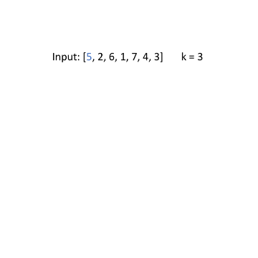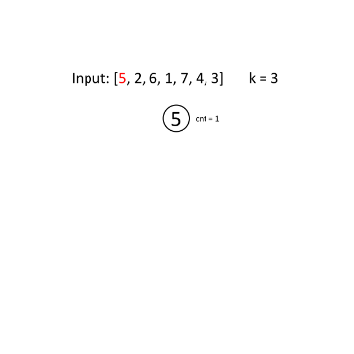

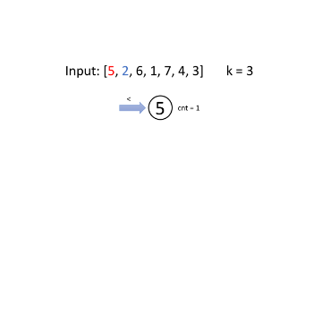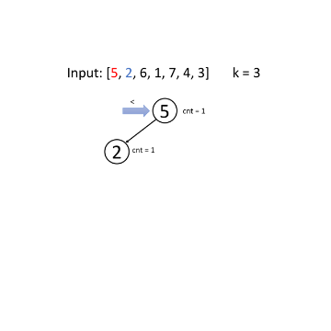

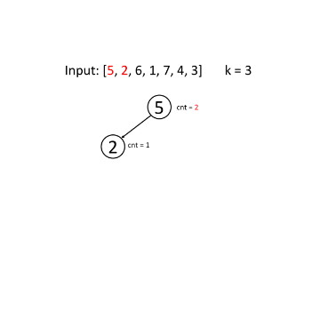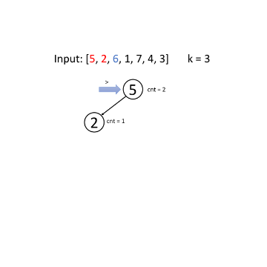

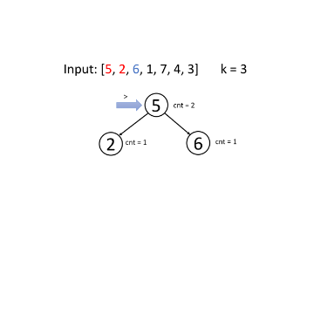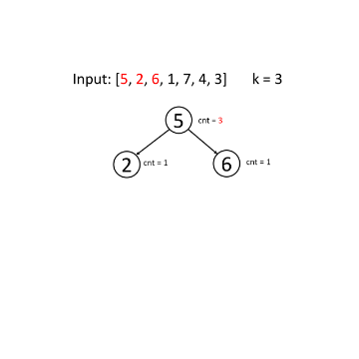

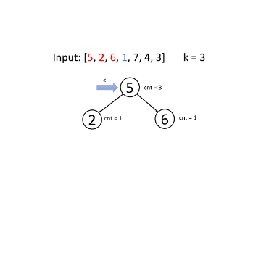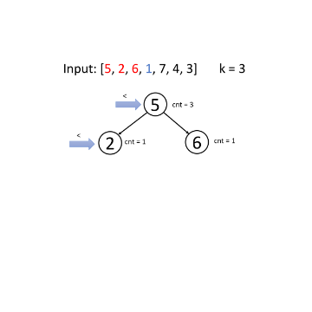

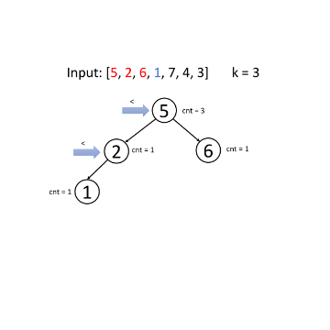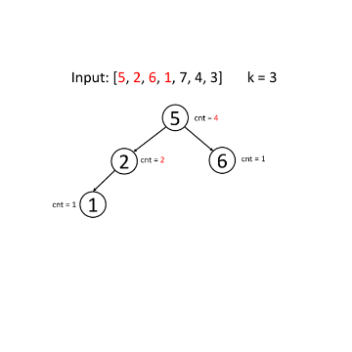

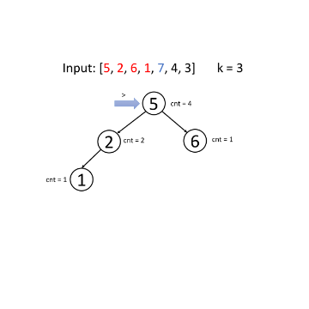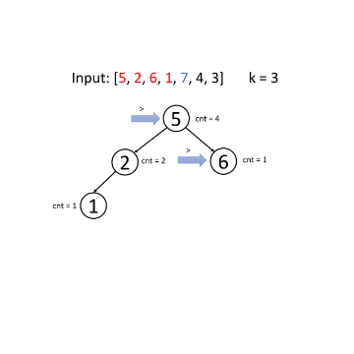

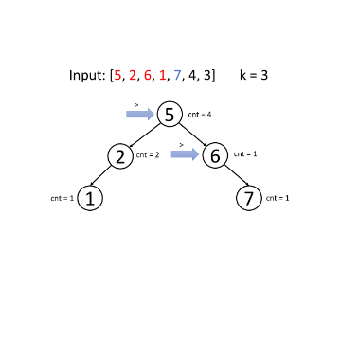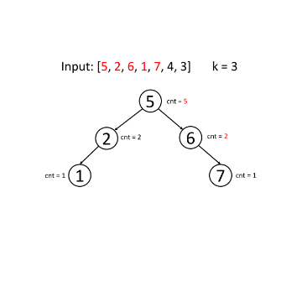

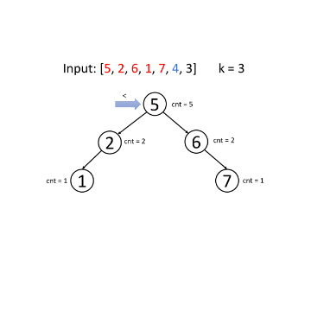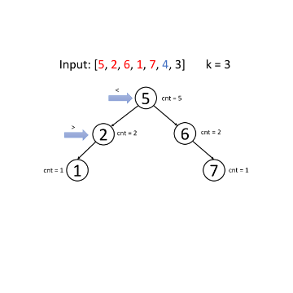

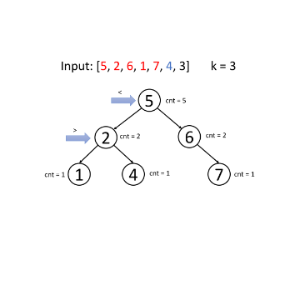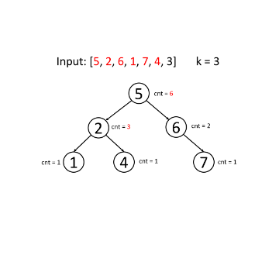

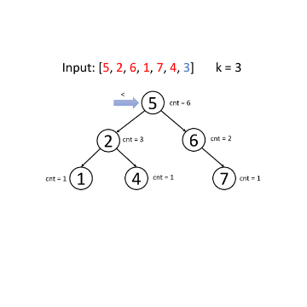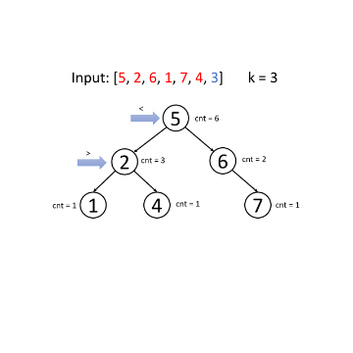

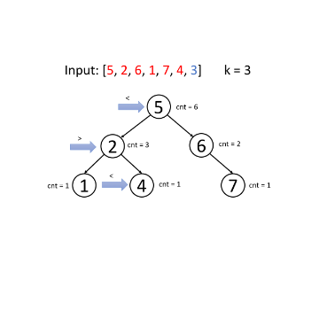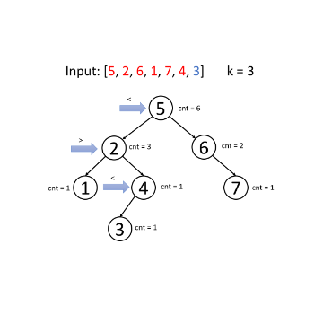

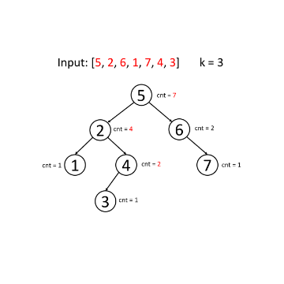

#### **2. Search**

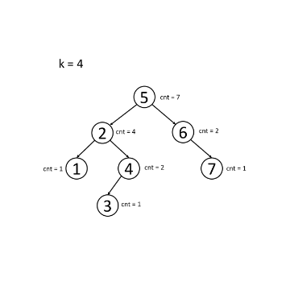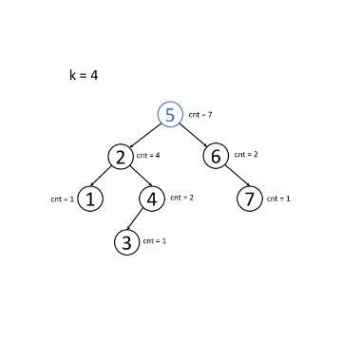

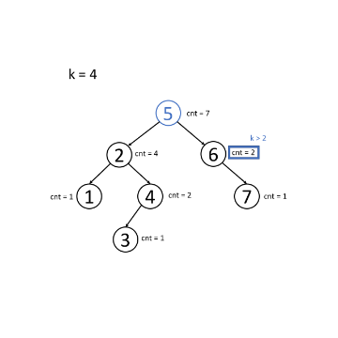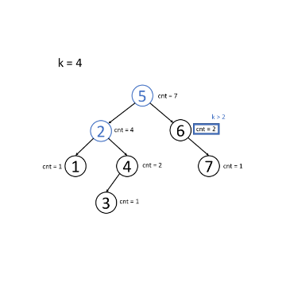

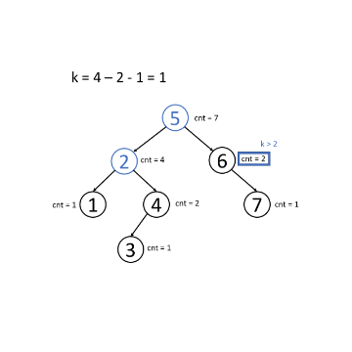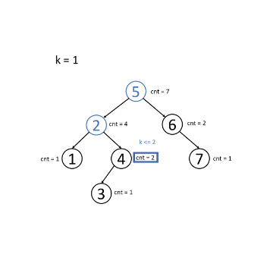

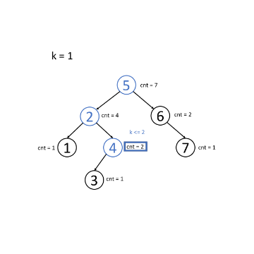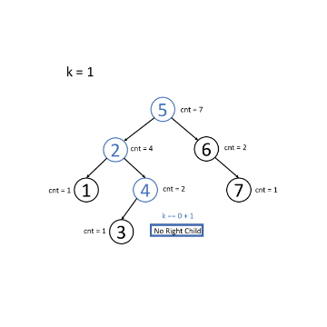

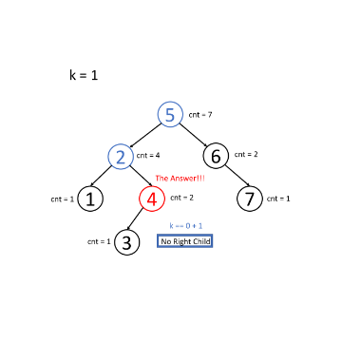

**Kth Largest Element in a Stream**

Design a class to find the kth largest element in a stream. Note that it is the kth largest element in the sorted order, not the kth distinct element.

Implement KthLargest class:

* KthLargest(int k, int[] nums) Initializes the object with the integer k and the stream of integers nums.
* int add(int val) Returns the element representing the kth largest element in the stream.

**Example 1:**

**Input**

["KthLargest", "add", "add", "add", "add", "add"]

[[3, [4, 5, 8, 2]], [3], [5], [10], [9], [4]]

**Output**

[null, 4, 5, 5, 8, 8]

**Explanation**

KthLargest kthLargest = new KthLargest(3, [4, 5, 8, 2]);

kthLargest.add(3); // return 4

kthLargest.add(5); // return 5

kthLargest.add(10); // return 5

kthLargest.add(9); // return 8

kthLargest.add(4); // return 8

**Constraints:**

* 1 <= k <= 104
* 0 <= nums.length <= 104
* -104 <= nums[i] <= 104
* -104 <= val <= 104
* At most 104 calls will be made to add.
* It is guaranteed that there will be at least k elements in the array when you search for the kth element.

**Kth Largest Element in a Stream - Solution**

Problem: Design a class to find the **k**th largest element in a stream.

We have mentioned the basic idea of the algorithm using the BST in the previous article. Here we provide java and C++ codes for your reference.

|  |
| --- |
| class KthLargest {  // insert a node into the BST  private Node insertNode(Node root, int num) {  if (root == null) {  return new Node(num, 1);  }  if (root.val < num) {  root.right = insertNode(root.right, num);  } else {  root.left = insertNode(root.left, num);  }  root.cnt++;  return root;  }  private int searchKth(Node root, int k) {  // m = the size of right subtree  int m = root.right != null ? root.right.cnt : 0;  // root is the m+1 largest node in the BST  if (k == m + 1) {  return root.val;  }  if (k <= m) {  // find kth largest in the right subtree  return searchKth(root.right, k);  } else {  // find (k-m-1)th largest in the left subtree  return searchKth(root.left, k - m - 1);  }  }    private Node root;  private int m_k;  public KthLargest(int k, int[] nums) {  root = null;  for (int i = 0; i < nums.length; ++i) {  root = insertNode(root, nums[i]);  }  m_k = k;  }    public int add(int val) {  root = insertNode(root, val);  return searchKth(root, m_k);  }  }  class Node { // the structure for the tree node  Node left;  Node right;  int val;  int cnt; // the size of the subtree rooted at the node  public Node (int v, int c) {  left = null;  right = null;  val = v;  cnt = c;  }  }  /**  * Your KthLargest object will be instantiated and called as such:  * KthLargest obj = new KthLargest(k, nums);  * int param_1 = obj.add(val);  */ |

By using a BST, the time complexity for insertion and search are both O(h). The time complexity of performing all the operations will be O(N*h). That is, O(N^2) in the worst case and O(NlogN) ideally.

If the BST is well organized, you can always keep h = logN, where h is the height of the tree and N is the total number of nodes. In that case, you can reduce the time complexity of search, insertion and deletion to O(logN) which is really a considerable solution in many cases. That's the idea of the height-balanced BST. We will introduce height-balanced BST in later chapters.

As we mentioned before, this algorithm is suitable if we have to handle both insertion and search operations.

**Lowest Common Ancestor of a Binary Search Tree**

Given a binary search tree (BST), find the lowest common ancestor (LCA) of two given nodes in the BST.

According to the [definition of LCA on Wikipedia](https://en.wikipedia.org/wiki/Lowest_common_ancestor): “The lowest common ancestor is defined between two nodes p and q as the lowest node in T that has both p and q as descendants (where we allow **a node to be a descendant of itself**).”

**Example 1:**



**Input:** root = [6,2,8,0,4,7,9,null,null,3,5], p = 2, q = 8

**Output:** 6

**Explanation:** The LCA of nodes 2 and 8 is 6.

**Example 2:**



**Input:** root = [6,2,8,0,4,7,9,null,null,3,5], p = 2, q = 4

**Output:** 2

**Explanation:** The LCA of nodes 2 and 4 is 2, since a node can be a descendant of itself according to the LCA definition.

**Example 3:**

**Input:** root = [2,1], p = 2, q = 1

**Output:** 2

**Constraints:**

* The number of nodes in the tree is in the range [2, 105].
* -109 <= Node.val <= 109
* All Node.val are **unique**.
* p != q
* p and q will exist in the BST.

## Solution

We can solve this using the approaches to find [LCA in a binary tree](https://leetcode.com/articles/lowest-common-ancestor-of-a-binary-tree/).

But, binary search tree's property could be utilized, to come up with a better algorithm.

Lets review properties of a BST:

1. Left subtree of a node N contains nodes whose values are lesser than or equal to node N's value.
2. Right subtree of a node N contains nodes whose values are greater than node N's value.
3. Both left and right subtrees are also BSTs.

#### **Approach 1: Recursive Approach**

**Intuition**

Lowest common ancestor for two nodes p and q would be the last ancestor node common to both of them. Here last is defined in terms of the depth of the node. The below diagram would help in understanding what lowest means.

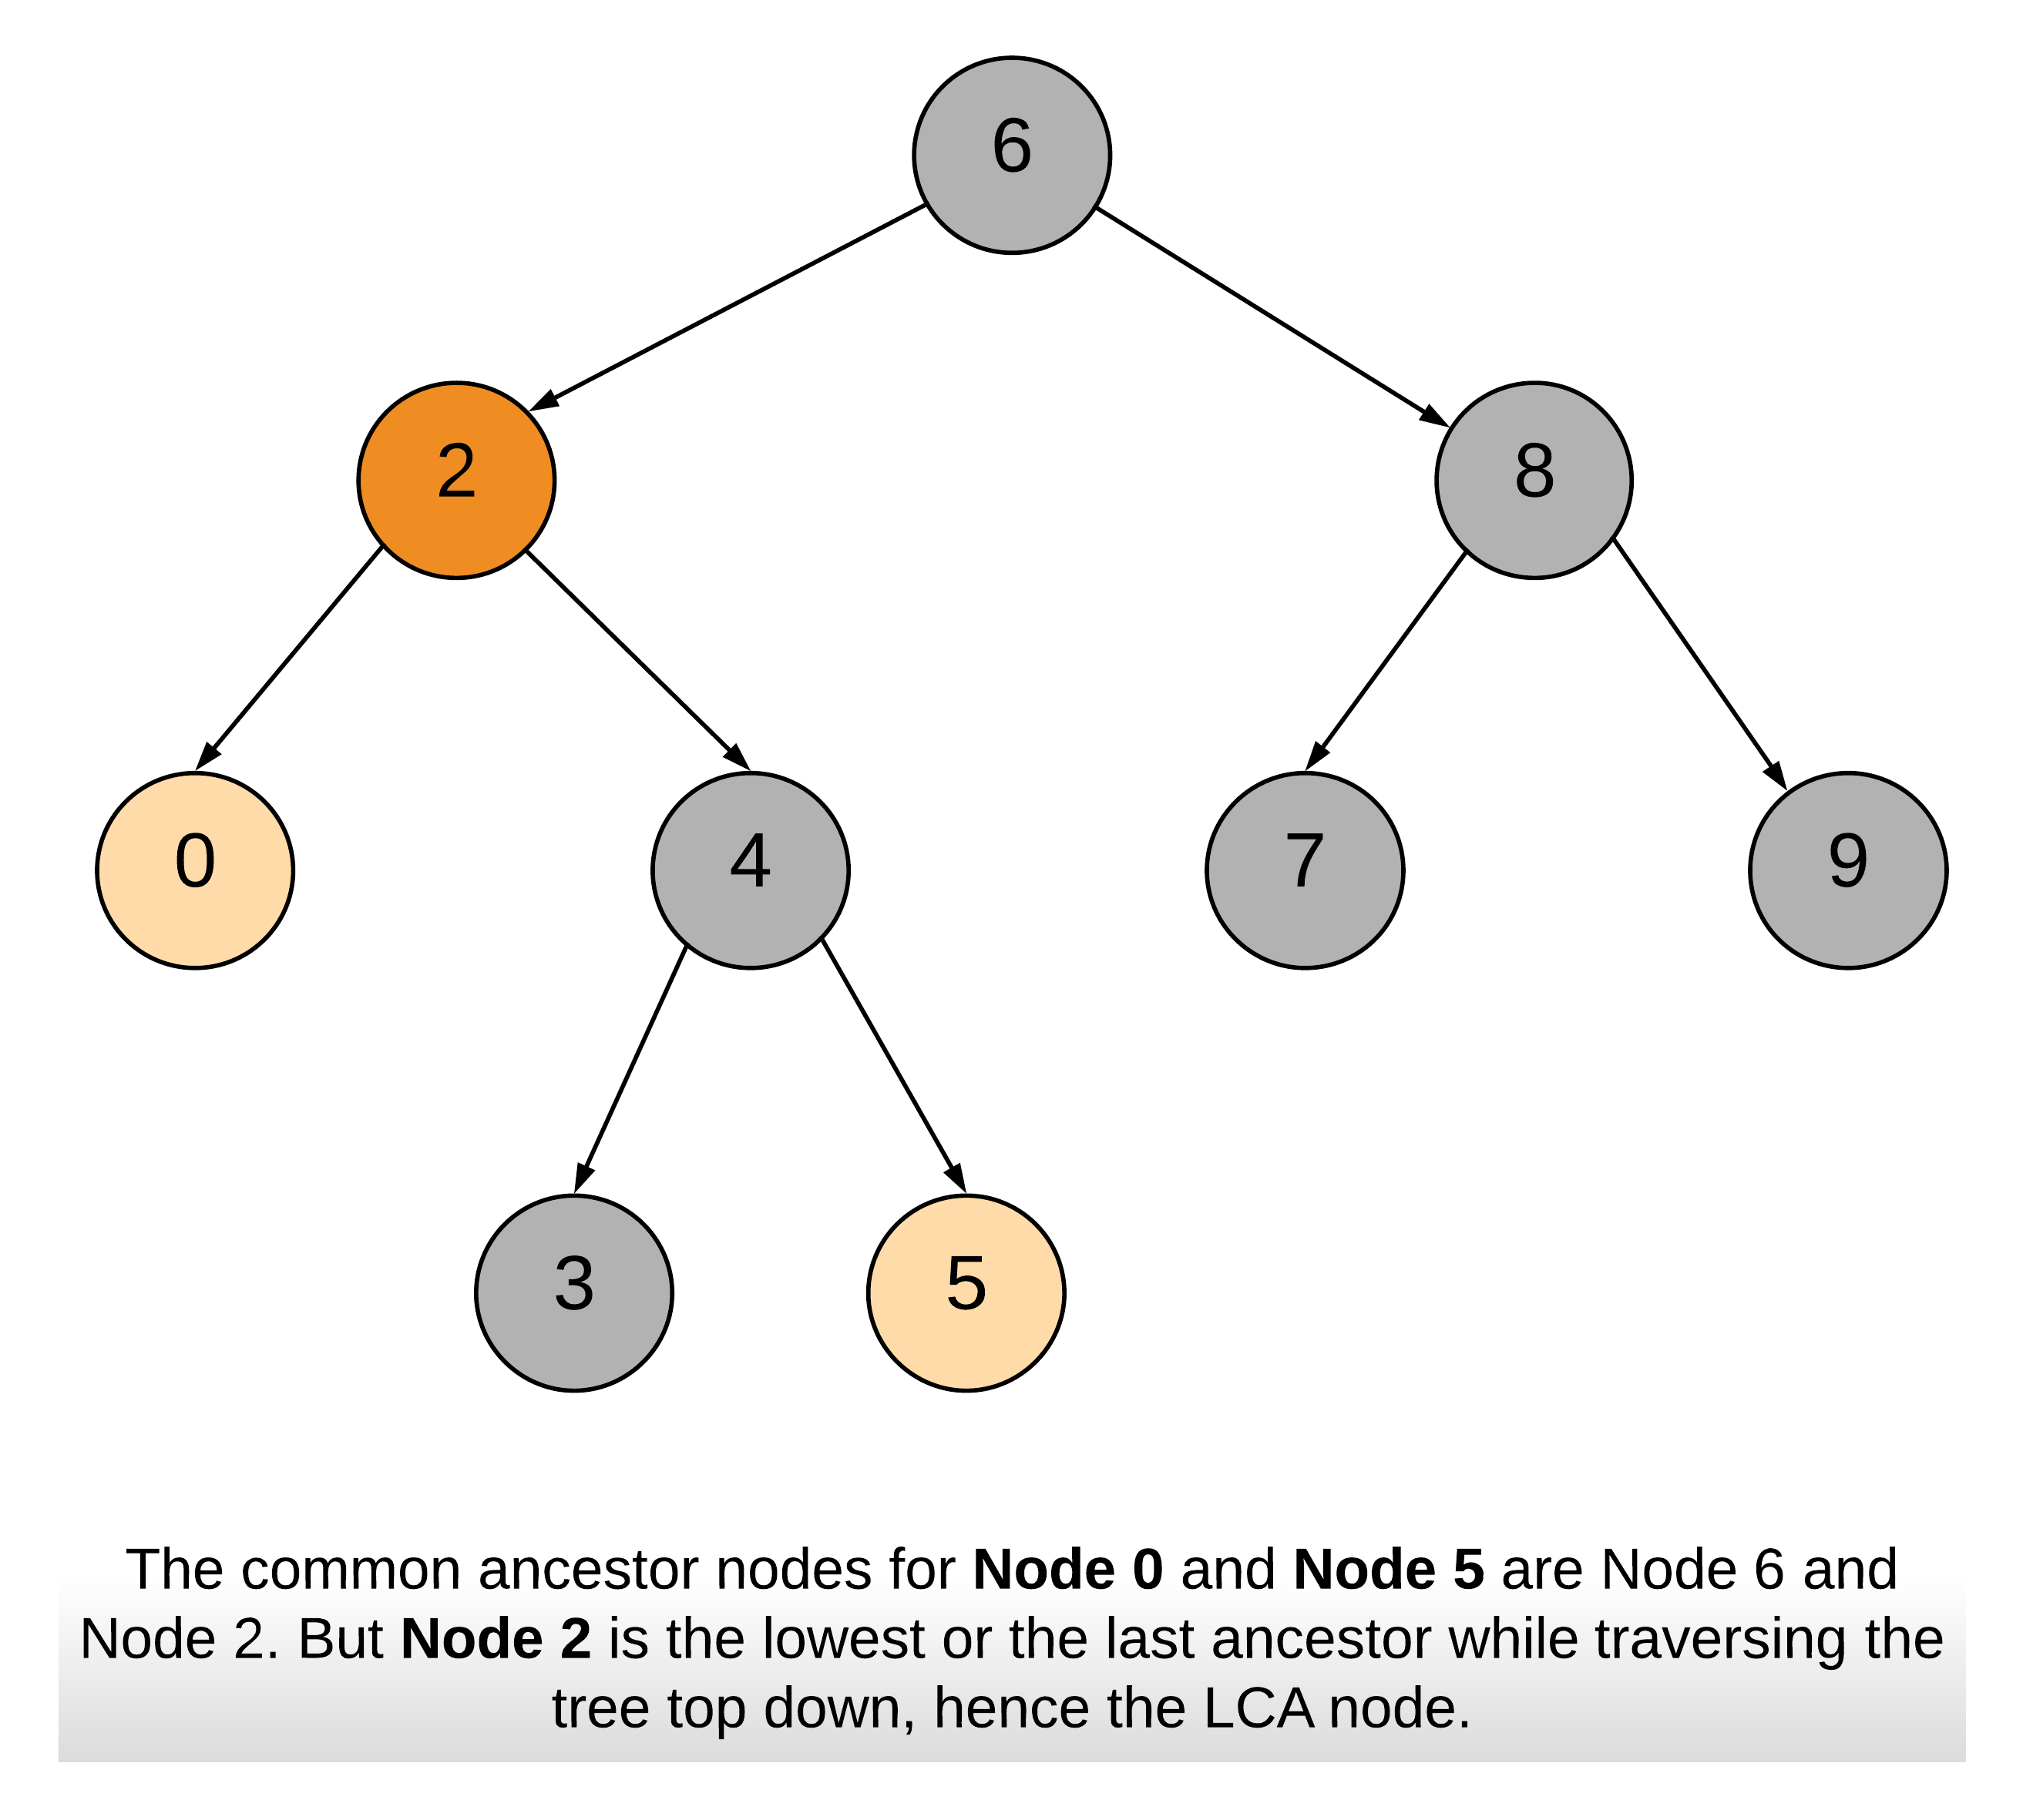

Note: One of p or q would be in the left subtree and the other in the right subtree of the LCA node.

Following cases are possible:

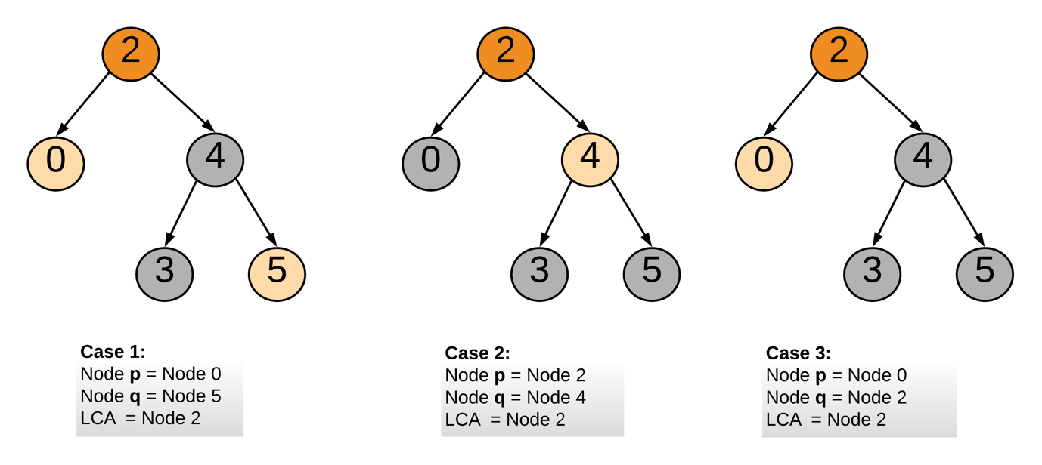

**Algorithm**

1. Start traversing the tree from the root node.
2. If both the nodes p and q are in the right subtree, then continue the search with right subtree starting step 1.
3. If both the nodes p and q are in the left subtree, then continue the search with left subtree starting step 1.
4. If both step 2 and step 3 are not true, this means we have found the node which is common to node p's and q's subtrees. and hence we return this common node as the LCA.

|  |
| --- |
| class Solution {  public TreeNode lowestCommonAncestor(TreeNode root, TreeNode p, TreeNode q) {  // Value of current node or parent node.  int parentVal = root.val;  // Value of p  int pVal = p.val;  // Value of q;  int qVal = q.val;  if (pVal > parentVal && qVal > parentVal) {  // If both p and q are greater than parent  return lowestCommonAncestor(root.right, p, q);  } else if (pVal < parentVal && qVal < parentVal) {  // If both p and q are lesser than parent  return lowestCommonAncestor(root.left, p, q);  } else {  // We have found the split point, i.e. the LCA node.  return root;  }  }  } |

**Complexity Analysis**

* Time Complexity: *O*(*N*), where *N* is the number of nodes in the BST. In the worst case we might be visiting all the nodes of the BST.
* Space Complexity: *O*(*N*). This is because the maximum amount of space utilized by the recursion stack would be *N* since the height of a skewed BST could be *N*.

#### **Approach 2: Iterative Approach**

**Algorithm**

The steps taken are also similar to approach 1. The only difference is instead of recursively calling the function, we traverse down the tree iteratively. This is possible without using a stack or recursion since we don't need to backtrace to find the LCA node. In essence of it the problem is iterative, it just wants us to find the split point. The point from where p and q won't be part of the same subtree or when one is the parent of the other.

|  |
| --- |
| class Solution {  public TreeNode lowestCommonAncestor(TreeNode root, TreeNode p, TreeNode q) {  // Value of p  int pVal = p.val;  // Value of q;  int qVal = q.val;  // Start from the root node of the tree  TreeNode node = root;  // Traverse the tree  while (node != null) {  // Value of ancestor/parent node.  int parentVal = node.val;  if (pVal > parentVal && qVal > parentVal) {  // If both p and q are greater than parent  node = node.right;  } else if (pVal < parentVal && qVal < parentVal) {  // If both p and q are lesser than parent  node = node.left;  } else {  // We have found the split point, i.e. the LCA node.  return node;  }  }  return null;  }  } |

**Complexity Analysis**

* Time Complexity : *O*(*N*), where *N* is the number of nodes in the BST. In the worst case we might be visiting all the nodes of the BST.
* Space Complexity : *O*(1).

**Contains Duplicate III**

Given an array of integers, find out whether there are two distinct indices *i* and *j* in the array such that the **absolute** difference between **nums[i]** and **nums[j]** is at most *t* and the **absolute** difference between *i* and *j* is at most *k*.

**Example 1:**

**Input:** nums = [1,2,3,1], k = 3, t = 0

**Output:** true

**Example 2:**

**Input:** nums = [1,0,1,1], k = 1, t = 2

**Output:** true

**Example 3:**

**Input:** nums = [1,5,9,1,5,9], k = 2, t = 3

**Output:** false

**Constraints:**

* 0 <= nums.length <= 2 * 104
* -231 <= nums[i] <= 231 - 1
* 0 <= k <= 104
* 0 <= t <= 231 - 1

Hint #1

Time complexity O(n logk) - This will give an indication that sorting is involved for k elements.

   Hide Hint #2

Use already existing state to evaluate next state - Like, a set of k sorted numbers are only needed to be tracked. When we are processing the next number in array, then we can utilize the existing sorted state and it is not necessary to sort next overlapping set of k numbers again.

## Summary

This article is for intermediate readers. It introduces the following ideas: Binary Search Tree, HashMap, and Buckets.

## Solutions

#### **Approach #1 (Naive Linear Search) [Time Limit Exceeded]**

**Intuition**

Compare each element with the previous k*k* elements and see if their difference is at most t*t*.

**Algorithm**

This problem requires us to find i*i* and j*j* such that the following conditions are satisfied:  
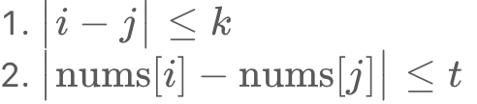

The naive approach is the same as [Approach #1 in Contains Duplicate II solution](https://leetcode.com/articles/contains-duplicate-ii/#approach-1-naive-linear-search-time-limit-exceeded), which keeps a virtual sliding window that holds the newest k*k* elements. In this way, [Condition 1](https://leetcode.com/problems/contains-duplicate-iii/solution/#condition-1) above is always satisfied. We then check if [Condition 2](https://leetcode.com/problems/contains-duplicate-iii/solution/#condition-2) is also satisfied by applying linear search.

|  |
| --- |
| public boolean containsNearbyAlmostDuplicate(int[] nums, int k, int t) {  for (int i = 0; i < nums.length; ++i) {  for (int j = Math.max(i - k, 0); j < i; ++j) {  if (Math.abs(nums[i] - nums[j]) <= t) return true;  }  }  return false;  }  // Time limit exceeded. |

**Complexity Analysis**

* Time complexity : *O*(*n* min(*k*,*n*)). It costs (min(*k*,*n*)) time for each linear search. Note that we do at most *n* comparisons in one search even if *k* can be larger than *n*.
* Space complexity : *O*(1). We only used constant auxiliary space.

#### **Approach #2 (Binary Search Tree) [Accepted]**

**Intuition**

* If elements in the window are maintained in sorted order, we can apply binary search twice to check if [Condition 2](https://leetcode.com/problems/contains-duplicate-iii/solution/#condition-2) is satisfied.
* By utilizing self-balancing Binary Search Tree, one can keep the window ordered at all times with logarithmic time insert and delete.

**Algorithm**

The real bottleneck of [Approach #1](https://leetcode.com/problems/contains-duplicate-iii/solution/#approach-1-naive-linear-search-time-limit-exceeded) is due to all elements in the sliding window are being scanned to check if [Condition 2](https://leetcode.com/problems/contains-duplicate-iii/solution/#condition-2) is satisfied. Could we do better?

If elements in the window are in sorted order, we can apply Binary Search twice to search for the two boundaries *x*+*t* and *x*−*t* for each element *x*.

Unfortunately, the window is unsorted. A common mistake here is attempting to maintain a sorted array. Although searching in a sorted array costs only logarithmic time, keeping the order of the elements after insert and delete operation is not as efficient. Imagine you have a sorted array with *k* elements and you are adding a new item *x*. Even if you can find the correct position in *O*(log*k*) time, you still need *O*(*k*) time to insert *x* into the sorted array. The reason is that you need to shift all elements after the insert position one step backward. The same reasoning applies to removal as well. After removing an item from position *i*, you need to shift all elements after i*i* one step forward. Thus, we gain nothing in speed compared to the [naive linear search approach](https://leetcode.com/problems/contains-duplicate-iii/solution/#approach-1-naive-linear-search-time-limit-exceeded) above.

To gain an actual speedup, we need a dynamic data structure that supports faster insert, search and delete. Self-balancing Binary Search Tree (BST) is the right data structure. The term Self-balancing means the tree automatically keeps its height small after arbitrary insert and delete operations. Why does self-balancing matter? That is because most operations on a BST take time directly proportional to the height of the tree. Take a look at the following non-balanced BST which is skewed to the left:  
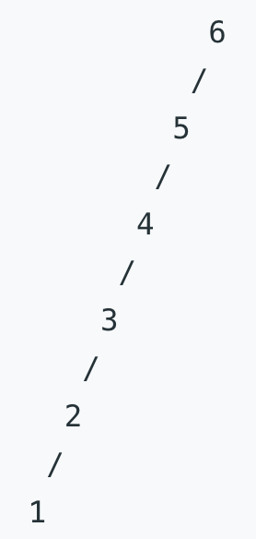

Figure 1. A non-balanced BST that is skewed to the left.

Searching in the above BST degrades to linear time, which is like searching in a linked list. Now compare to the BST below which is balanced:

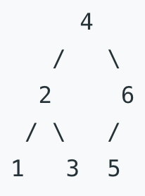

Figure 2. A balanced BST.

Assume that *n* is the total number of nodes in the tree, a balanced binary tree maintains its height in the order of *h*=log*n*. Thus it supports *O*(*h*)=*O*(log*n*) time for each of insert, search and delete operations.

Here is the entire algorithm in pseudocode:

* Initialize an empty BST set
* Loop through the array, for each element *x*
  + Find the smallest element *s* in set that is greater than or equal to *x*, return true if *s*−*x*≤*t*
  + Find the greatest element *g* in set that is smaller than or equal to *x*, return true if *x*−*g*≤*t*
  + Put *x* in set
  + If the size of the set is larger than *k*, remove the oldest item.
* Return false

One may consider the smallest element s*s* that is greater or equal to *x* as the successor of *x* in the BST, as in: "What is the next greater value of *x*?". Similarly, we consider the greatest element *g* that is smaller or equal to x*x* as the predecessor of *x* in the BST, as in: "What is the previous smaller value of *x*?". These two values *s* and *g* are the two closest neighbors from *x*. Thus by checking the distance from them to *x*, we can conclude if [Condition 2](https://leetcode.com/problems/contains-duplicate-iii/solution/#condition-2) is satisfied.

|  |
| --- |
| public boolean containsNearbyAlmostDuplicate(int[] nums, int k, int t) {  TreeSet<Integer> set = new TreeSet<>();  for (int i = 0; i < nums.length; ++i) {  // Find the successor of current element  Integer s = set.ceiling(nums[i]);  if (s != null && s <= nums[i] + t) return true;  // Find the predecessor of current element  Integer g = set.floor(nums[i]);  if (g != null && nums[i] <= g + t) return true;  set.add(nums[i]);  if (set.size() > k) {  set.remove(nums[i - k]);  }  }  return false;  } |

**Complexity Analysis**

* Time complexity : *O*(*n*log(min(*n*,*k*))). We iterate through the array of size *n*. For each iteration, it costs *O*(logmin(*k*,*n*)) time (search, insert or delete) in the BST, since the size of the BST is upper bounded by both k*k* and *n*.
* Space complexity : *O*(min(*n*,*k*)). Space is dominated by the size of the BST, which is upper bounded by both *k* and *n*.

**Note**

* When the array's elements and t*t*'s value are large, they can cause overflow in arithmetic operation. Consider using a larger size data type instead, such as long.
* C++'s std::set, std::set::upper_bound and std::set::lower_bound are equivalent to Java's TreeSet, TreeSet::ceiling and TreeSet::floor, respectively. Python does not provide a Self-balancing BST through its library.

#### **Approach #3 (Buckets) [Accepted]**

**Intuition**

Inspired by bucket sort, we can achieve linear time complexity in our problem using buckets as window.

**Algorithm**

Bucket sort is a sorting algorithm that works by distributing the elements of an array into a number of buckets. Each bucket is then sorted individually, using a different sorting algorithm. Here is an illustration of buckets.

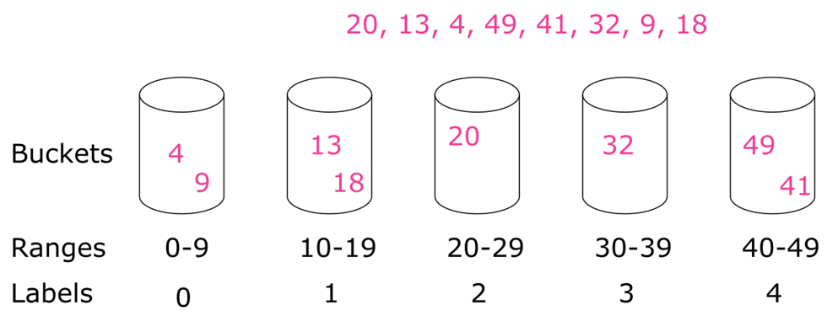

Figure 3. Illustration of buckets.

From the above example, we have 8 unsorted integers. We create 5 buckets covering the inclusive ranges of 0,9],[10,19],[20,29],[30,39],[40,49] individually. Each of the eight elements is in a particular bucket. For element with value x*x*, its bucket label is *x*/*w* and here we have *w*=10. Sort each bucket using some other sorting algorithm and then collect all of them bucket by bucket.

Back to our problem, the critical issue we are trying to solve is:

1. For a given element x*x* is there an item in the window that is within the range of [*x*−*t*,*x*+*t*]?
2. Could we do this in constant time?

Let us consider an example where each element is a person's birthday. Your birthday, say some day in March, is the new element x*x*. Suppose that each month has 30 days and you want to know if anyone has a birthday within *t*=30 days of yours. Immediately, we can rule out all other months except February, March, April.

The reason we know this is because each birthday belongs to a bucket we called month! And the range covered by the buckets are the same as distance *t* which simplifies things a lot. Any two elements that are not in the same or adjacent buckets must have a distance greater than *t*.

We apply the above bucketing principle and design buckets covering the ranges of [0,*t*],[*t*+1,2*t*+1],.... We keep the window using this buckets. Then, each time, all we need to check is the bucket that x*x* belongs to and its two adjacent buckets. Thus, we have a constant time algorithm for searching almost duplicate in the window.

One thing worth mentioning is the difference from bucket sort – Each of our buckets contains at most one element at any time, because two elements in a bucket means "almost duplicate" and we can return early from the function. Therefore, a HashMap with an element associated with a bucket label is enough for our purpose.

|  |
| --- |
| public class Solution {  // Get the ID of the bucket from element value x and bucket width w  // In Java, `-3 / 5 = 0` and but we need `-3 / 5 = -1`.  private long getID(long x, long w) {  return x < 0 ? (x + 1) / w - 1 : x / w;  }  public boolean containsNearbyAlmostDuplicate(int[] nums, int k, int t) {  if (t < 0) return false;  Map<Long, Long> d = new HashMap<>();  long w = (long)t + 1;  for (int i = 0; i < nums.length; ++i) {  long m = getID(nums[i], w);  // check if bucket m is empty, each bucket may contain at most one element  if (d.containsKey(m))  return true;  // check the neighbor buckets for almost duplicate  if (d.containsKey(m - 1) && Math.abs(nums[i] - d.get(m - 1)) < w)  return true;  if (d.containsKey(m + 1) && Math.abs(nums[i] - d.get(m + 1)) < w)  return true;  // now bucket m is empty and no almost duplicate in neighbor buckets  d.put(m, (long)nums[i]);  if (i >= k) d.remove(getID(nums[i - k], w));  }  return false;  }  } |

**Complexity Analysis**

* Time complexity : *O*(*n*). For each of the *n* elements, we do at most three searches, one insert, and one delete on the HashMap, which costs constant time on average. Thus, the entire algorithm costs *O*(*n*) time.
* Space complexity : *O*(min(*n*,*k*)). Space is dominated by the HashMap, which is linear to the size of its elements. The size of the HashMap is upper bounded by both *n* and *k*. Thus the space complexity is *O*(min(*n*,*k*)).

## See Also

* [Problem 217 Contains Duplicate](https://leetcode.com/articles/contains-duplicate/)
* [Problem 219 Contains Duplicate II](https://leetcode.com/articles/contains-duplicate-ii/)

## Appendix: Height-balanced BST

As we mentioned before, the complexity of operations in a BST varies according to the height of the tree. Therefore, we will introduce a new concept, Height-balanced Binary Search Tree.

After this chapter, you should be able to:

1. Understand the concept of the height-balanced BST;
2. Explain how the height-balanced BST apply in practical application.

**Introduction to the Height-Balanced BST**

In this article, we are going to help you understand the general concept of a balanced BST.

### ***What is a Height-Balanced BST?***

Terminology used in trees:

* Depth of node - the number of edges from the tree's root node to the node
* Height of node - the number of edges on the longest path between that node and a leaf
* Height of Tree - the height of its root node

A height-balanced (or self-balancing) binary search tree is a binary search tree that automatically keeps its height small in the face of arbitrary item insertions and deletions. That is, the height of a balanced BST with N nodes is always logN. Also, the height of the two subtrees of every node never differs by more than 1.

Why logN?

* A binary tree with height h contains at most   
  .
* In other word, a binary tree with N nodes and height h:   
  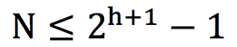.
* That is: 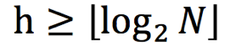.

Here is an example of a normal BST and a height-balanced BST:

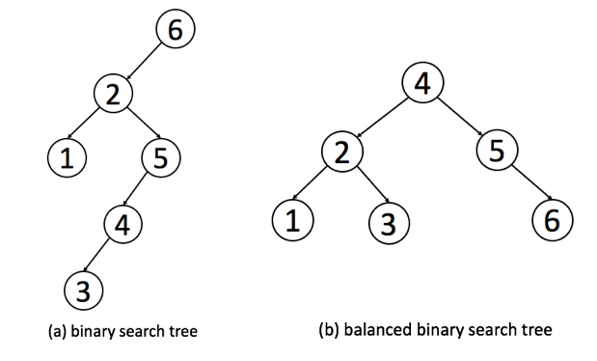

Using the definition, we can determine if a BST is height-balanced ([Balanced Binary Tree](https://leetcode.com/problems/balanced-binary-tree/description/)).

As we mentioned before, the height of a balanced BST with N nodes is always logN. We can calculate the total number of nodes and the height of the tree to determine if this BST is a height-balanced BST.

Also, in the definition, we mentioned a property of height-balanced BST: the depth of the two subtrees of every node never differ by more than 1. We can also validate the tree recursively according to this rule.

### ***Why Using a Height-Balanced BST?***

We have introduced binary search tree and related operations, including search, insertion and deletion in the previous article. When we analyze the time complexity of these operations, it is worth noting that the height of the tree is the most important factor. Taking search operation as an example, if the height of the BST is *h*, the time complexity will be O(h). The height of the BST really matters.

So let's discuss the relationship between the number of nodes N and the height of the tree h. For a height-balanced BST, as we discussed in the previous section, 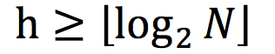 . But for a normal BST, in the worst case, it can degenerate into a chain.

Therefore, the height of a BST with N nodes can vary from logN to N. That is, the time complexity of search operation can vary from logN to N. It is a huge difference in the performance.

Therefore, a height-balanced BST play an important role in improving the performance.

### ***How to Implement a Height-Balanced BST?***

There are several different implementations for height-balanced BSTs. The details of these implementations are different but they have similar goals:

1. The data structure should satisfy the binary search property and the height-balanced property.
2. The data structure should support the basic operations of BST, including search, insertion and deletion within O(*logN*) time even in worst case.

We provide a list of popular height-balanced BSTs for your reference:

* [Red-black tree](https://en.wikipedia.org/wiki/Red%E2%80%93black_tree)
* [AVL tree](https://en.wikipedia.org/wiki/AVL_tre)
* [Splay tree](https://en.wikipedia.org/wiki/Splay_tree)
* [Treap](https://en.wikipedia.org/wiki/Treap)

We are not going to talk about the details of these implementations in this article series.

### ***Practical Application of the Height-balanced BST***

The height-balanced BST is widely used in practice since it can provide search, insertion and deletion operations all in O(logN) time complexity.

The most profound use is in set/map. The principle of set and map are similar. We will focus on the set in the following discussion.

Set is another data structure which can store a lot of keys without any particular order or any duplicate elements. The basic operations it should support are to insert new elements into the set and to check if an element is in the set or not.

Typically, there are two kinds of sets which are widely used: hash set and tree set.

The tree set, TreeSet in Java or set in C++, is implemented by the height-balanced BST. Therefore, the time complexity of search, insertion and deletion are all O(logN).

The hash set, HashSet in Java or unordered_set in C++, is implemented by hash, but the height-balanced BST also plays an important role in hash set. When there are too many elements with the same hash key, it will cost O(N) time complexity to look up for a specific element, where N is the number of elements with the same hash key. Typically, the height-balanced BST will be used here to improve the performance from O(N) to O(logN).

 The essential difference between the hash set and the tree set is that keys in the tree set are ordered.

### ***Conclusion***

A height-balanced BST is a special form of BST which aims at improving the performance. The details of implementations are outside the scope of this article series and are not required in most interviews. But it is useful to understand the general idea of a height-balanced BST and how height-balanced BSTs can help you in your algorithm designs.

**Balanced Binary Tree**

Given a binary tree, determine if it is height-balanced.

For this problem, a height-balanced binary tree is defined as:

a binary tree in which the left and right subtrees of *every* node differ in height by no more than 1.

**Example 1:**

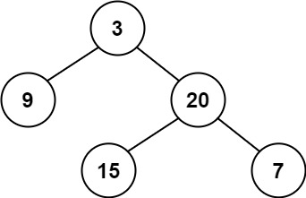

**Input:** root = [3,9,20,null,null,15,7]

**Output:** true

**Example 2:**

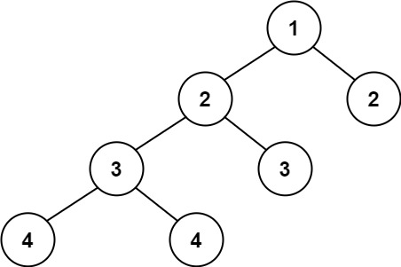

**Input:** root = [1,2,2,3,3,null,null,4,4]

**Output:** false

**Example 3:**

**Input:** root = []

**Output:** true

**Constraints:**

* The number of nodes in the tree is in the range [0, 5000].
* -104 <= Node.val <= 104

## Solution

Given the definition of a balanced tree we know that a tree *T* is not balanced if and only if there is some node *p*∈*T* such that ∣height(*p*.*left*)−height(*p*.*right*)∣>1. The tree below has each node is labeled by its height, as well as the unbalanced subtree highlighted.

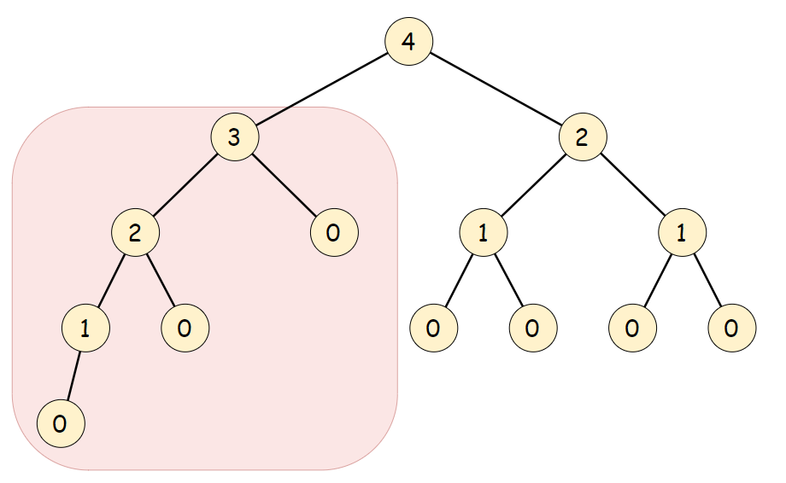

The balanced subtree definition hints at the fact that we should treat each subtree as a subproblem. The question is: in which order should we solve the subproblems?

#### **Approach 1: Top-down recursion**

**Algorithm**

First we define a function height such that for any node *p*∈*T*

Now that we have a method for determining the height of a tree, all that remains is to compare the height of every node's children. A tree *T* rooted at *r* is balanced if and only if the height of its two children are within 1 of each other and the subtrees at each child are also balanced. Therefore, we can compare the two child subtrees' heights then recurse on each one.

|  |
| --- |
| isBalanced(root):  if (root == NULL):  return true  if (abs(height(root.left) - height(root.right)) > 1):  return false  else:  return isBalanced(root.left) && isBalanced(root.right) |

|  |
| --- |
| class Solution {  // Recursively obtain the height of a tree. An empty tree has -1 height  private int height(TreeNode root) {  // An empty tree has height -1  if (root == null) {  return -1;  }  return 1 + Math.max(height(root.left), height(root.right));  }  public boolean isBalanced(TreeNode root) {  // An empty tree satisfies the definition of a balanced tree  if (root == null) {  return true;  }  // Check if subtrees have height within 1. If they do, check if the  // subtrees are balanced  return Math.abs(height(root.left) - height(root.right)) < 2  && isBalanced(root.left)  && isBalanced(root.right);  }  }; |

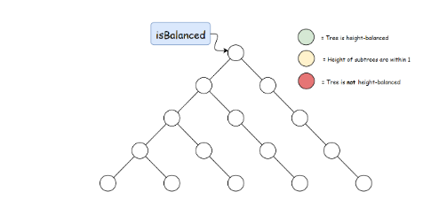

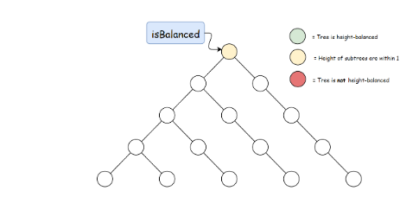

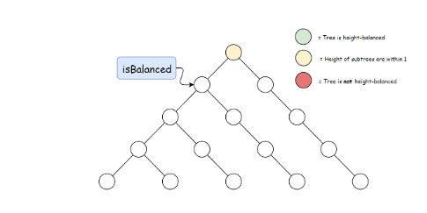

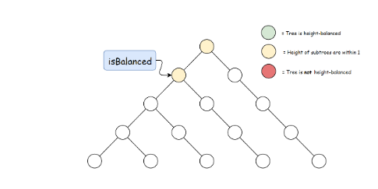

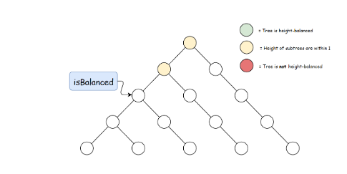

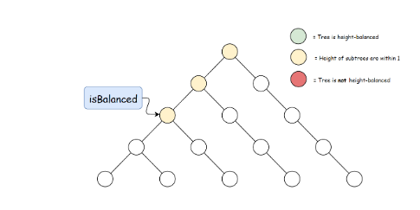

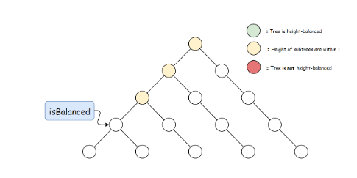

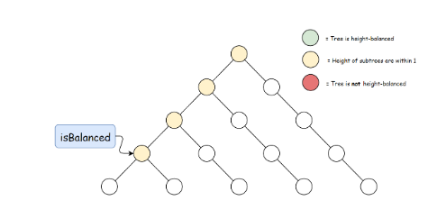

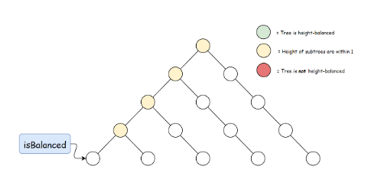

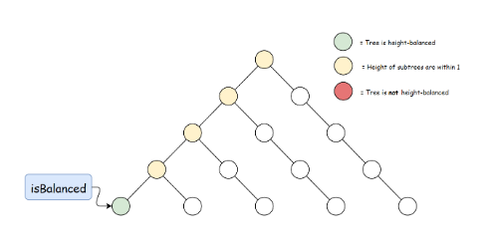

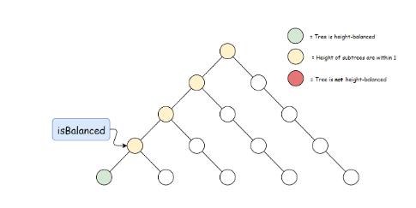

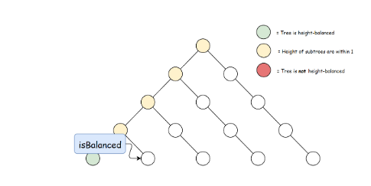

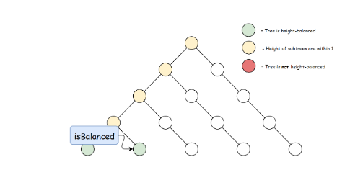

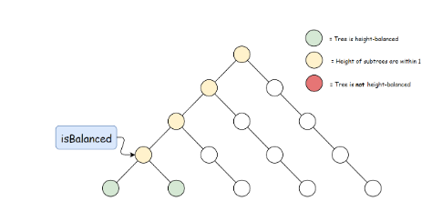

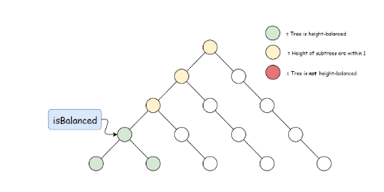

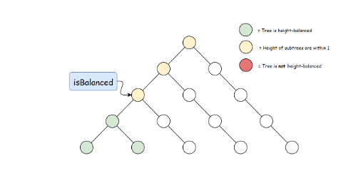

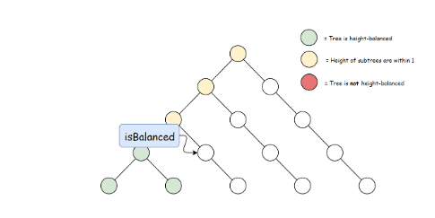

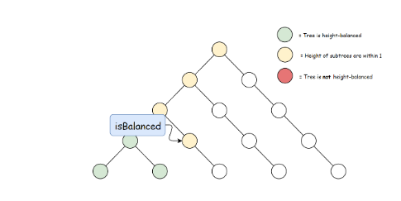

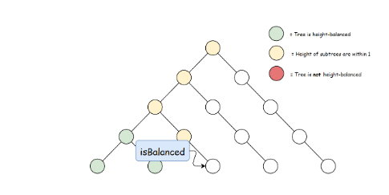

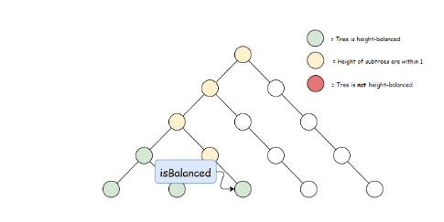

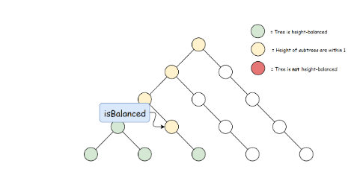

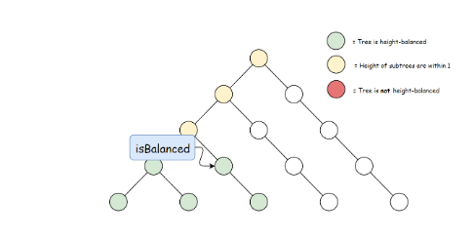

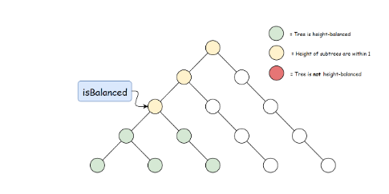

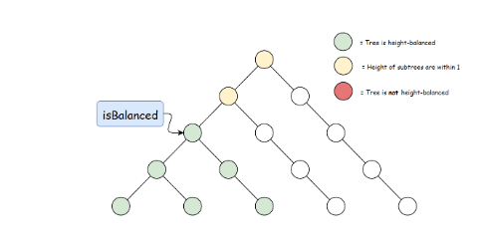

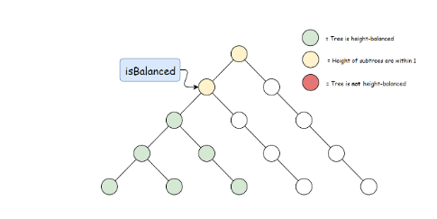

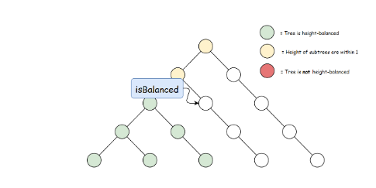

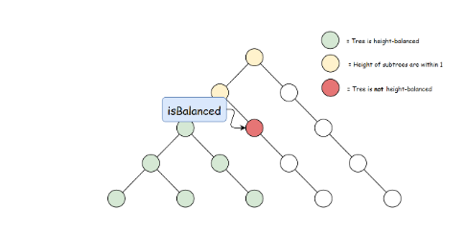

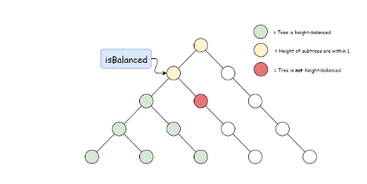

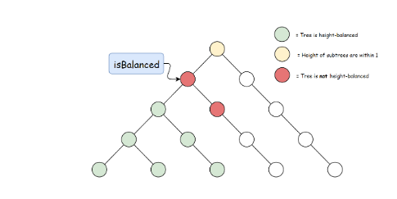

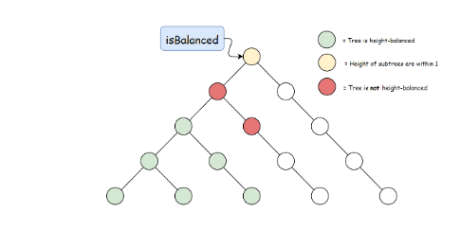

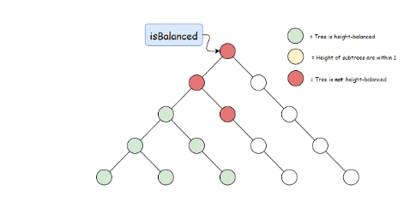

**Complexity Analysis**

* Time complexity : O(*n*log*n*)
  + For a node *p* at depth *d*, height(*p*) will be called *d* times.
  + We first need to obtain a bound on the height of a balanced tree. Let *f*(*h*) represent the minimum number of nodes in a balanced tree with height *h*. We have the relation

*f*(*h*)=*f*(*h*−1)+*f*(*h*−2)+1

which looks nearly identical to the Fibonacci recurrence relation. In fact, the complexity analysis for *f*(*h*) is similar and we claim that the lower bound is 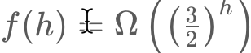.

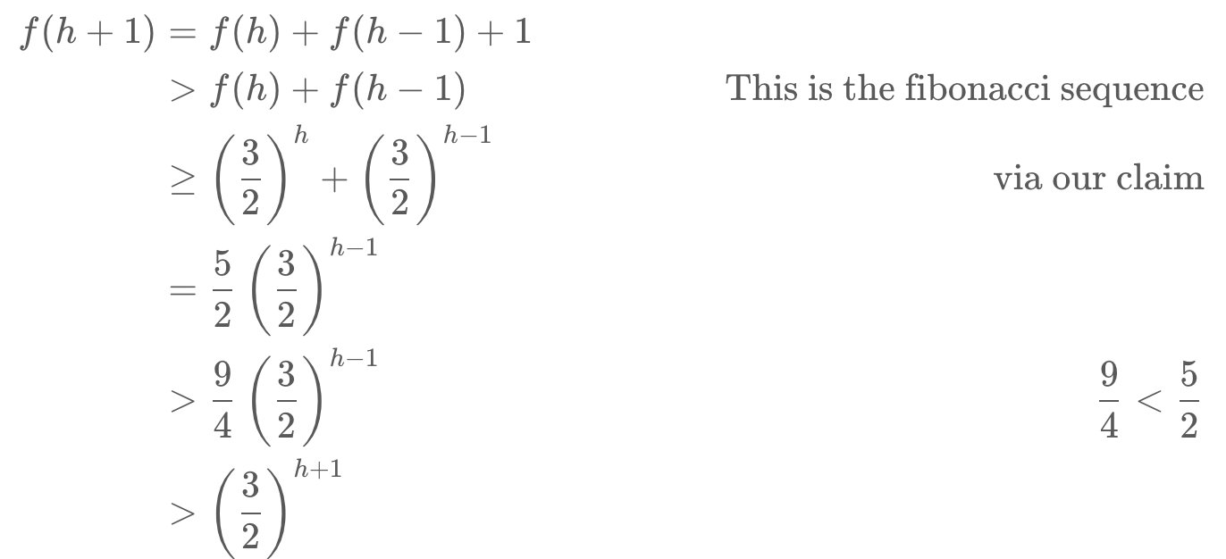  
  
Therefore, the height *h* of a balanced tree is bounded by O(log1.5​(*n*)). With this bound we can guarantee that height will be called on each node O(log*n*) times.

* + If our algorithm didn't have any early-stopping, we may end up having O(n^2) complexity if our tree is skewed since height is bounded by O(*n*). However, it is important to note that we stop recursion as soon as the height of a node's children are not within 1. In fact, in the skewed-tree case our algorithm is bounded by O(*n*), as it only checks the height of the first two subtrees.
* Space complexity : O(*n*). The recursion stack may contain all nodes if the tree is skewed.

**Fun fact**: *f*(*n*)=*f*(*n*−1)+*f*(*n*−2)+1 is known as a [Fibonacci meanders](http://oeis.org/wiki/User:Peter_Luschny/FibonacciMeanders) sequence.

#### **Approach 2: Bottom-up recursion**

**Intuition**

In approach 1, we perform redundant calculations when computing \texttt{height}height. In each call to \texttt{height}height, we require that the subtree's heights also be computed. Therefore, when working top down we will compute the height of a subtree once for every parent. We can remove the redundancy by first recursing on the children of the current node and then using their computed height to determine whether the current node is balanced.

**Algorithm**

We will use the same \texttt{height}height defined in the first approach. The bottom-up approach is a reverse of the logic of the top-down approach since we first check if the child subtrees are balanced before comparing their heights. The algorithm is as follows:

Check if the child subtrees are balanced. If they are, use their heights to determine if the current subtree is balanced as well as to calculate the current subtree's height.

|  |
| --- |
| // Utility class to store information from recursive calls  final class TreeInfo {  public final int height;  public final boolean balanced;  public TreeInfo(int height, boolean balanced) {  this.height = height;  this.balanced = balanced;  }  }  class Solution {  // Return whether or not the tree at root is balanced while also storing  // the tree's height in a reference variable.  private TreeInfo isBalancedTreeHelper(TreeNode root) {  // An empty tree is balanced and has height = -1  if (root == null) {  return new TreeInfo(-1, true);  }  // Check subtrees to see if they are balanced.  TreeInfo left = isBalancedTreeHelper(root.left);  if (!left.balanced) {  return new TreeInfo(-1, false);  }  TreeInfo right = isBalancedTreeHelper(root.right);  if (!right.balanced) {  return new TreeInfo(-1, false);  }  // Use the height obtained from the recursive calls to  // determine if the current node is also balanced.  if (Math.abs(left.height - right.height) < 2) {  return new TreeInfo(Math.max(left.height, right.height) + 1, true);  }  return new TreeInfo(-1, false);  }  public boolean isBalanced(TreeNode root) {  return isBalancedTreeHelper(root).balanced;  }  }; |

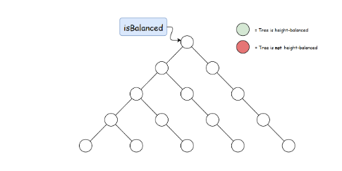

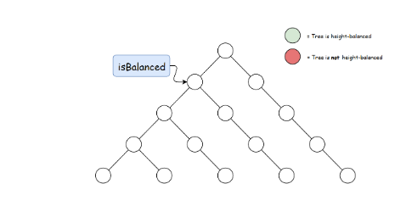

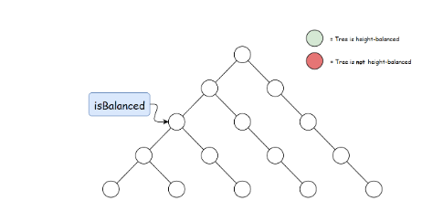

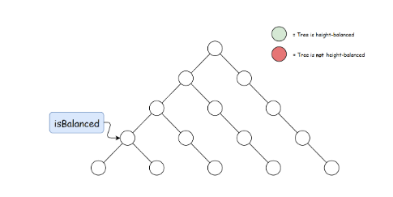

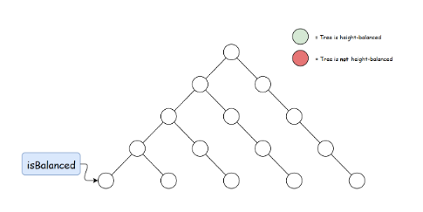

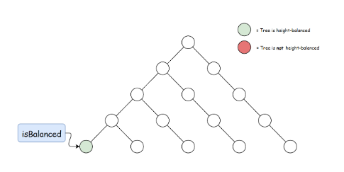

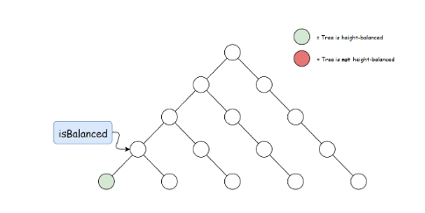

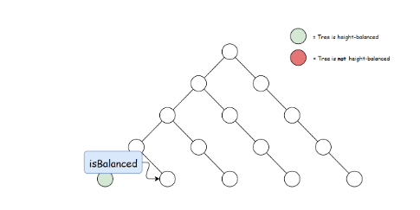

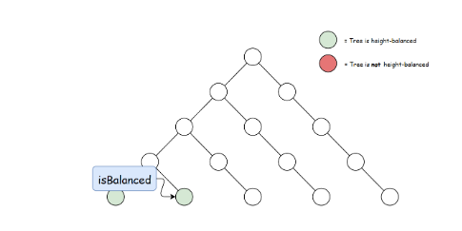

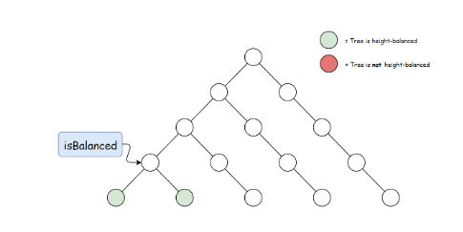

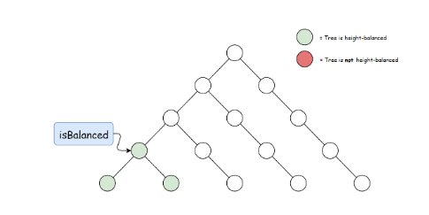

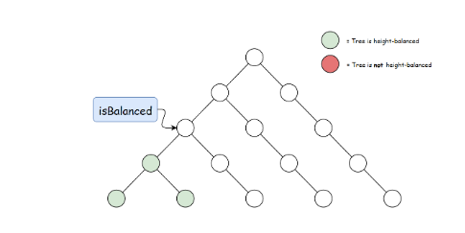

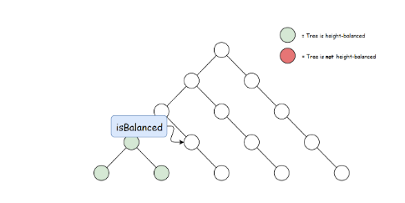

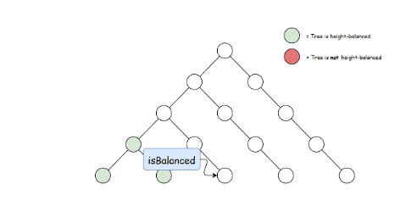

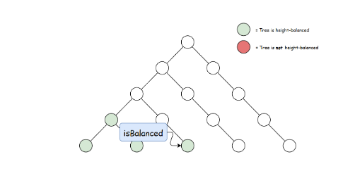

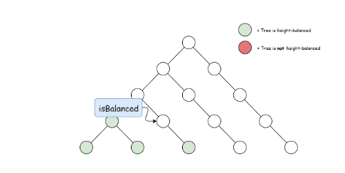

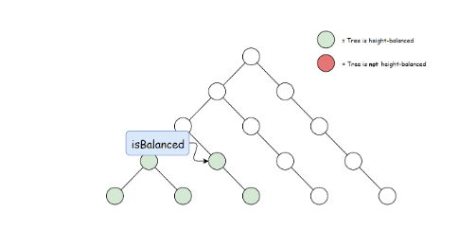

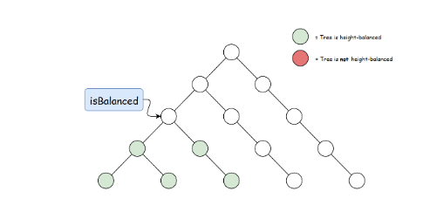

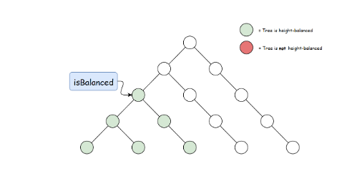

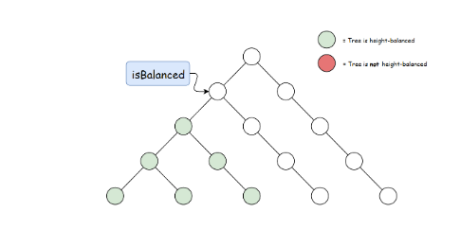

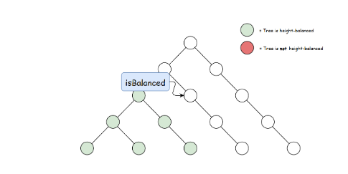

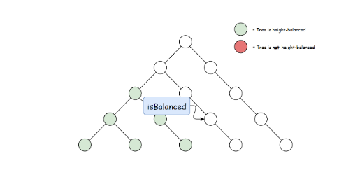

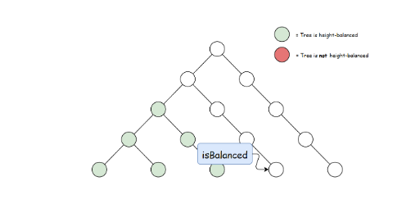

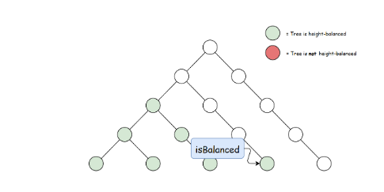

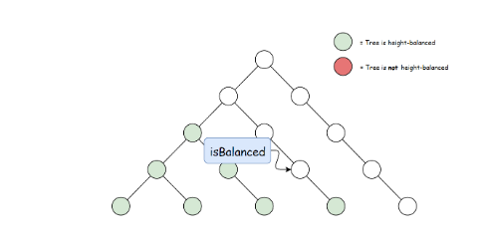

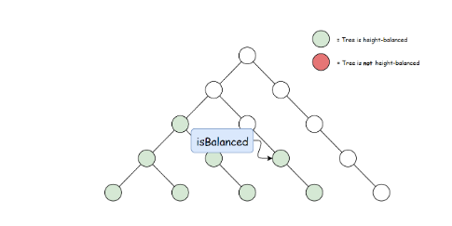

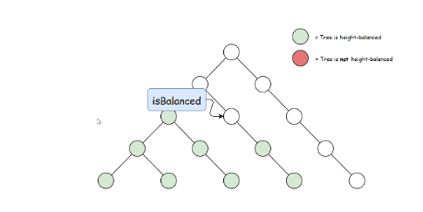

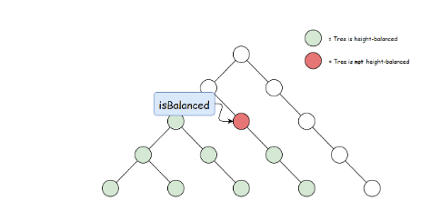

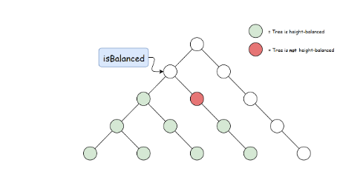

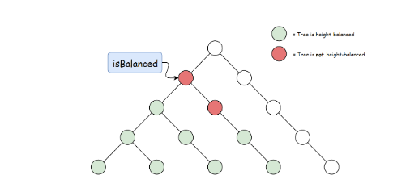

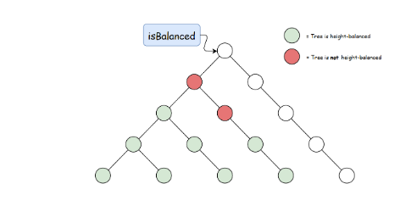

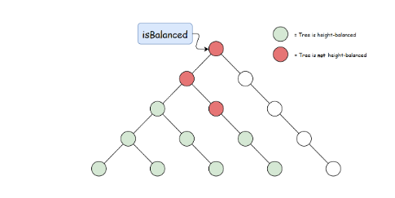

**Complexity Analysis**

* Time complexity : O(*n*)

For every subtree, we compute its height in constant time as well as compare the height of its children.

* Space complexity : O(*n*). The recursion stack may go up to O(*n*) if the tree is unbalanced.

**Convert Sorted Array to Binary Search Tree**

Given an array where elements are sorted in ascending order, convert it to a height balanced BST.

For this problem, a height-balanced binary tree is defined as a binary tree in which the depth of the two subtrees of *every* node never differ by more than 1.

**Example:**

Given the sorted array: [-10,-3,0,5,9],

One possible answer is: [0,-3,9,-10,null,5], which represents the following height balanced BST:

0

/ \

-3 9

/ /

-10 5

## Solution

#### **How to Traverse the Tree. DFS: Preorder, Inorder, Postorder; BFS.**

There are two general strategies to traverse a tree:

* Depth First Search (DFS)

In this strategy, we adopt the depth as the priority, so that one would start from a root and reach all the way down to certain leaf, and then back to root to reach another branch.

The DFS strategy can further be distinguished as preorder, inorder, and postorder depending on the relative order among the root node, left node and right node.

* Breadth First Search (BFS)

We scan through the tree level by level, following the order of height, from top to bottom. The nodes on higher level would be visited before the ones with lower levels.

On the following figure the nodes are enumerated in the order you visit them, please follow 1-2-3-4-5 to compare different strategies.

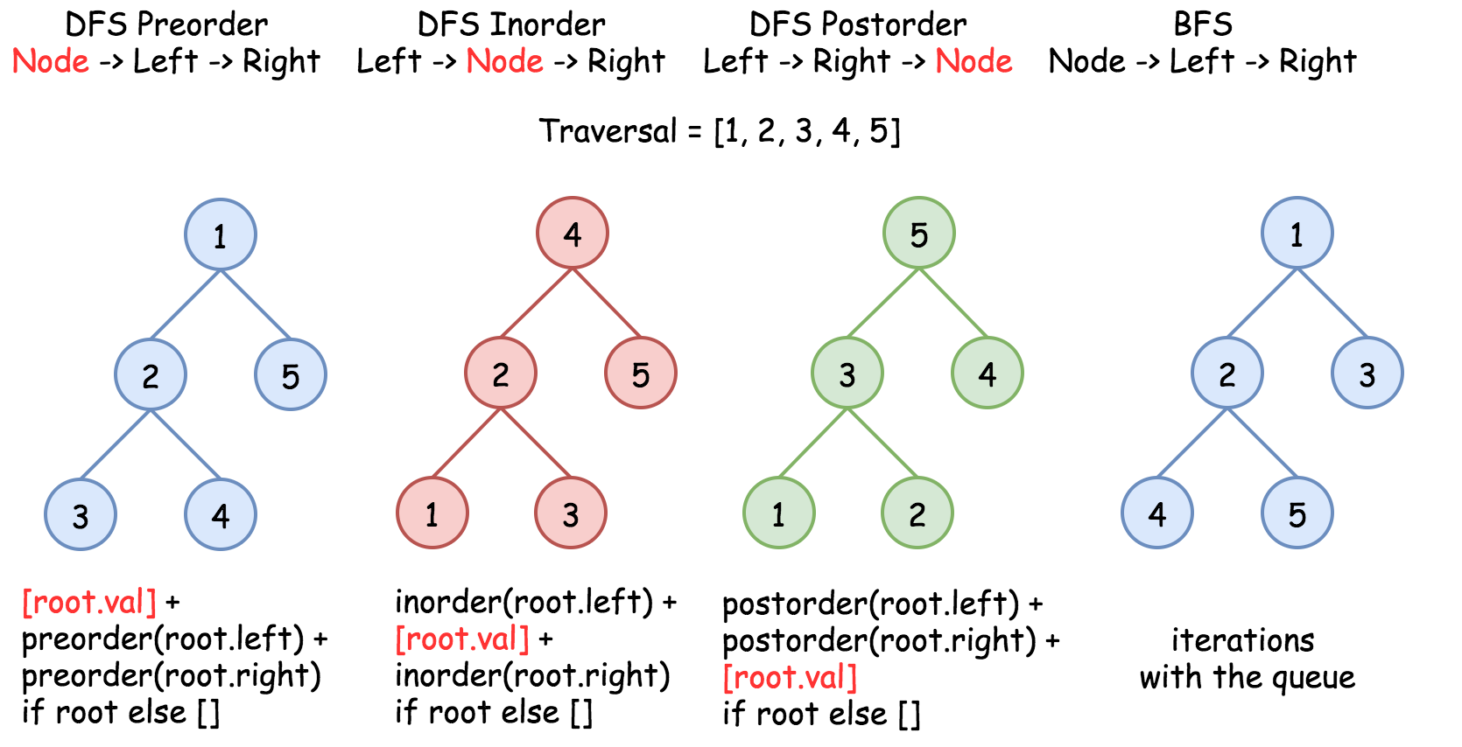

#### **Construct BST from Inorder Traversal: Why the Solution is Not Unique**

It's known that [inorder traversal of BST is an array sorted in the ascending order](https://leetcode.com/articles/delete-node-in-a-bst/).

Having sorted array as an input, we could rewrite the problem as Construct Binary Search Tree from Inorder Traversal.

Does this problem have a unique solution, i.e. could inorder traversal be used as a unique identifier to encore/decode BST? The answer is no.

Here is the funny thing about BST. Inorder traversal is not a unique identifier of BST. At the same time both preorder and postorder traversals are unique identifiers of BST. [From these traversals one could restore the inorder one](https://leetcode.com/articles/construct-bst-from-preorder-traversal/): inorder = sorted(postorder) = sorted(preorder), and [inorder + postorder or inorder + preorder are both unique identifiers of whatever binary tree](https://leetcode.com/articles/construct-binary-tree-from-inorder-and-postorder-t/).

So, the problem "sorted array -> BST" has multiple solutions.

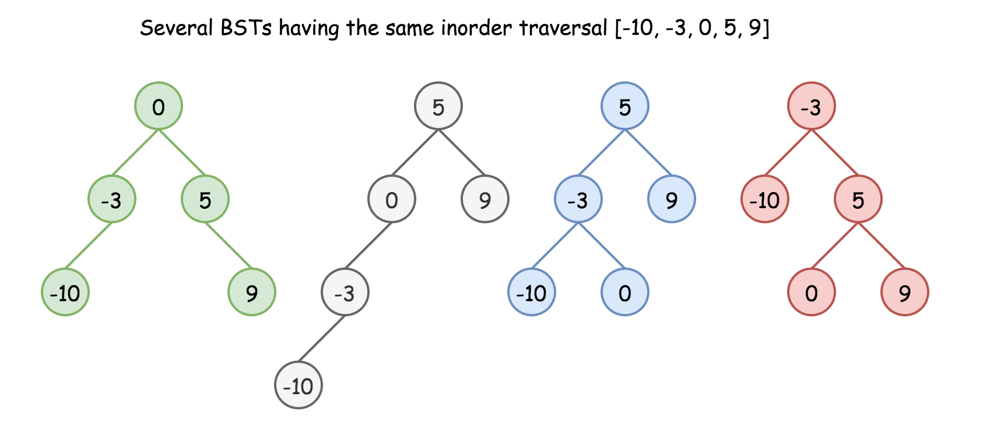

Here we have an additional condition: the tree should be height-balanced, i.e. the depths of the two subtrees of every node never differ by more than 1.

Does it make the solution to be unique? Still no.

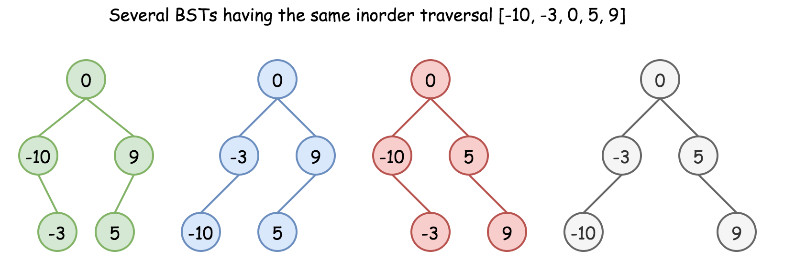

Basically, the height-balanced restriction means that at each step one has to pick up the number in the middle as a root. That works fine with arrays containing odd number of elements but there is no predefined choice for arrays with even number of elements.

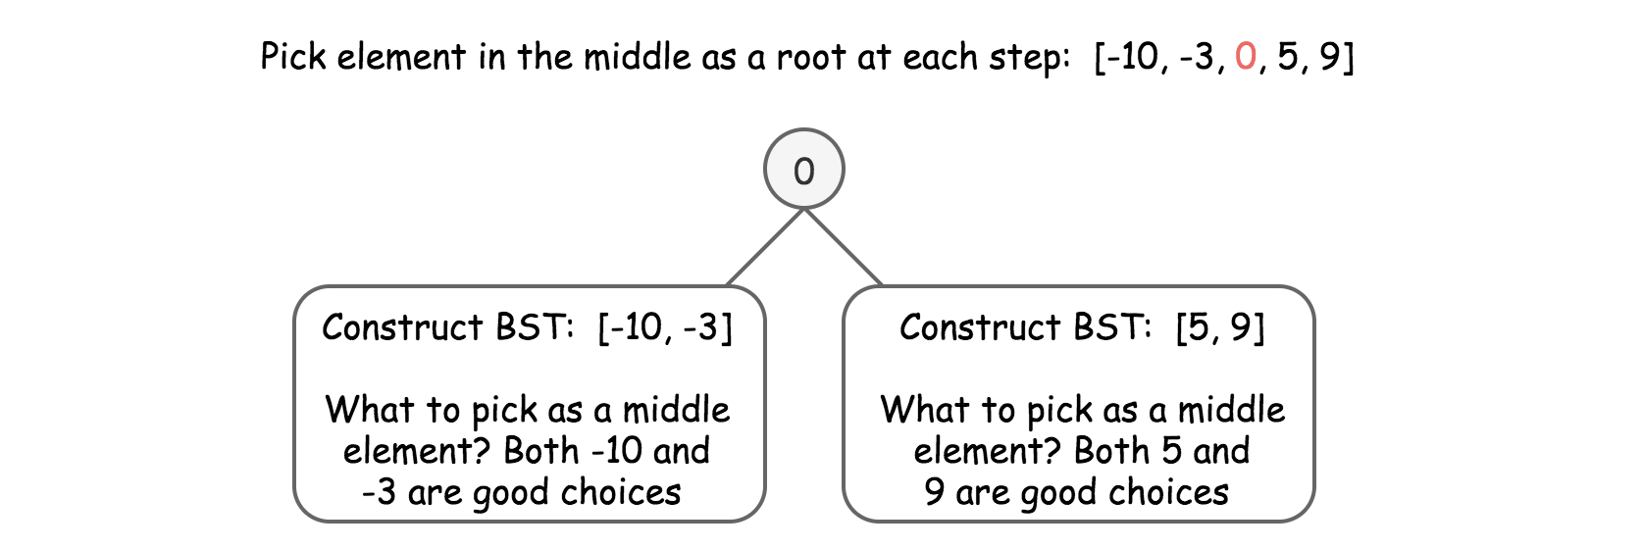

One could choose left middle element, or right middle one, and both choices will lead to different height-balanced BSTs. Let's see that in practice: in Approach 1 we will always pick up left middle element, in Approach 2 - right middle one. That will generate different BSTs but both solutions will be accepted.

#### **Approach 1: Preorder Traversal: Always Choose Left Middle Node as a Root**

**Algorithm**

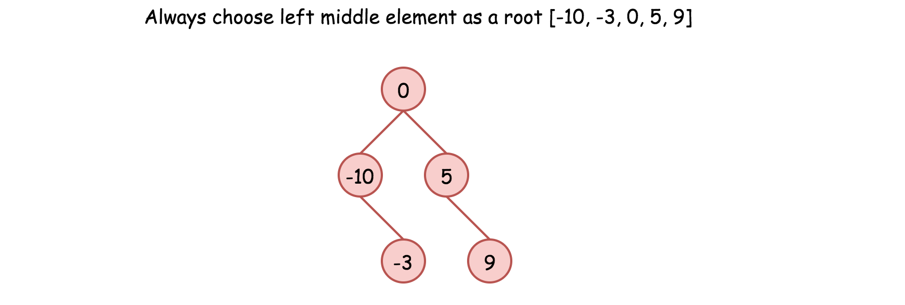

* Implement helper function helper(left, right), which constructs BST from nums elements between indexes left and right:
  + If left > right, then there is no elements available for that subtree. Return None.
  + Pick left middle element: p = (left + right) // 2.
  + Initiate the root: root = TreeNode(nums[p]).
  + Compute recursively left and right subtrees: root.left = helper(left, p - 1), root.right = helper(p + 1, right).
* Return helper(0, len(nums) - 1).

**Implementation**

|  |
| --- |
| class Solution {  int[] nums;  public TreeNode helper(int left, int right) {  if (left > right) return null;  // always choose left middle node as a root  int p = (left + right) / 2;  // preorder traversal: node -> left -> right  TreeNode root = new TreeNode(nums[p]);  root.left = helper(left, p - 1);  root.right = helper(p + 1, right);  return root;  }  public TreeNode sortedArrayToBST(int[] nums) {  this.nums = nums;  return helper(0, nums.length - 1);  }  } |

**Complexity Analysis**

* Time complexity: O(*N*) since we visit each node exactly once.
* Space complexity: O(*N*). O(*N*) to keep the output, and O(log*N*) for the recursion stack.

#### **Approach 2: Preorder Traversal: Always Choose Right Middle Node as a Root**

**Algorithm**

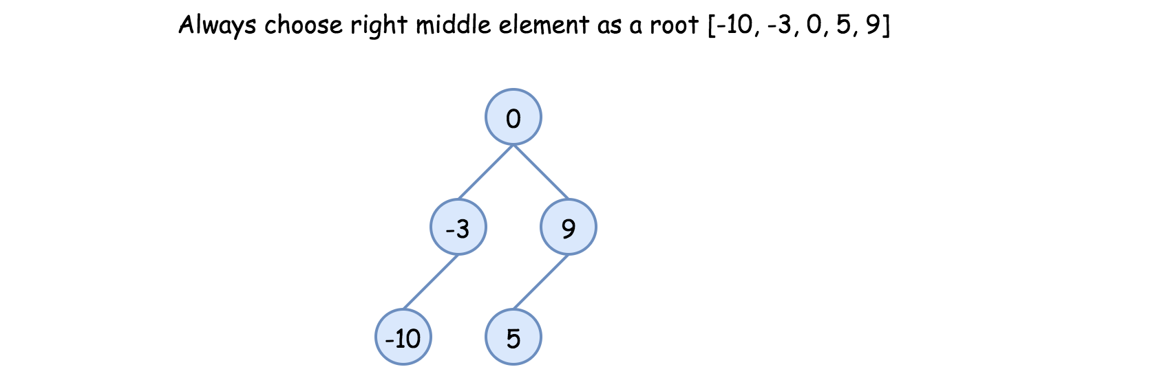

* Implement helper function helper(left, right), which constructs BST from nums elements between indexes left and right:
  + If left > right, then there is no elements available for that subtree. Return None.
  + Pick right middle element:
    - p = (left + right) // 2.
    - If left + right is odd, add 1 to p-index.
  + Initiate the root: root = TreeNode(nums[p]).
  + Compute recursively left and right subtrees: root.left = helper(left, p - 1), root.right = helper(p + 1, right).
* Return helper(0, len(nums) - 1).

**Implementation**

|  |
| --- |
| class Solution {  int[] nums;  public TreeNode helper(int left, int right) {  if (left > right) return null;  // always choose right middle node as a root  int p = (left + right) / 2;  if ((left + right) % 2 == 1) ++p;  // preorder traversal: node -> left -> right  TreeNode root = new TreeNode(nums[p]);  root.left = helper(left, p - 1);  root.right = helper(p + 1, right);  return root;  }  public TreeNode sortedArrayToBST(int[] nums) {  this.nums = nums;  return helper(0, nums.length - 1);  }  } |

**Complexity Analysis**

* Time complexity: O(*N*) since we visit each node exactly once.
* Space complexity: O(*N*) to keep the output, and O(log*N*) for the recursion stack.

#### **Approach 3: Preorder Traversal: Choose Random Middle Node as a Root**

This one is for fun. Instead of predefined choice we will pick randomly left or right middle node at each step. Each run will result in different solution and they all will be accepted.

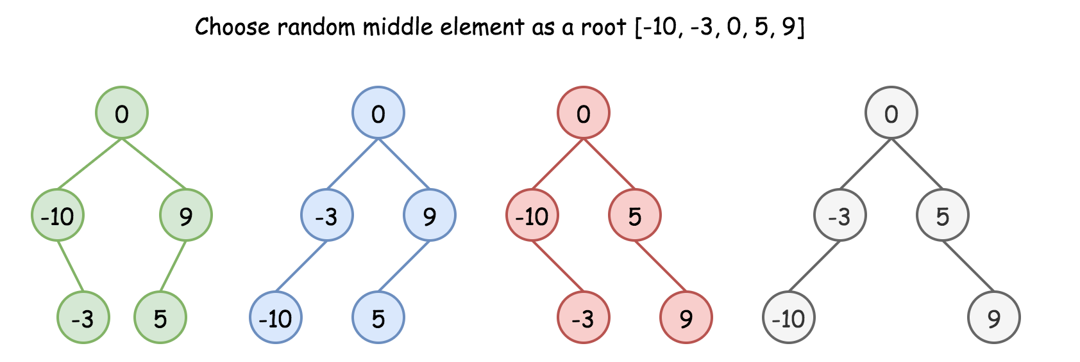

**Algorithm**

* Implement helper function helper(left, right), which constructs BST from nums elements between indexes left and right:
  + If left > right, then there is no elements available for that subtree. Return None.
  + Pick random middle element:
    - p = (left + right) // 2.
    - If left + right is odd, add randomly 0 or 1 to p-index.
  + Initiate the root: root = TreeNode(nums[p]).
  + Compute recursively left and right subtrees: root.left = helper(left, p - 1), root.right = helper(p + 1, right).
* Return helper(0, len(nums) - 1).

**Implementation**

|  |
| --- |
| class Solution {  int[] nums;  Random rand = new Random();    public TreeNode helper(int left, int right) {  if (left > right) return null;    // choose random middle node as a root  int p = (left + right) / 2;  if ((left + right) % 2 == 1) p += rand.nextInt(2);  // preorder traversal: node -> left -> right  TreeNode root = new TreeNode(nums[p]);  root.left = helper(left, p - 1);  root.right = helper(p + 1, right);  return root;  }    public TreeNode sortedArrayToBST(int[] nums) {  this.nums = nums;  return helper(0, nums.length - 1);  }  } |

**Complexity Analysis**

* Time complexity: O(*N*) since we visit each node exactly once.
* Space complexity: O(*N*) to keep the output, and O(log*N*) for the recursion stack.